TENDER REPETITION
FOR THE AWARD OF PROCUREMENT OF HUMAN RESOURCES MANAGEMENT SYSTEM (HRMS)


Important Note: Interested Parties are invited to express their interest of participation until Friday 30rd December 2016 included and at 14:00 hours either by email (procurement@olp.gr, kazatzisp@olp.gr and/or by fax (+30 210 4550187) by providing their full contact details.

Important Note: Interested Parties are invited to express their interest of participation until Friday 30rd December 2016 included and at 14:00 hours either by email (procurement@olp.gr, kazatzisp@olp.gr and/or by fax (+30 210 4550187) by providing their full contact details.

Piraeus, Greece, 17 May 2018
Important Note: Interested Parties are invited to express their interest of participation until Friday 30rd December 2016 included and at 14:00 hours either by email (procurement@olp.gr, kazatzisp@olp.gr and/or by fax (+30 210 4550187) by providing their full contact details.

Important Note: Interested Parties are invited to express their interest of participation until Friday 30rd December 2016 included and at 14:00 hours either by email (procurement@olp.gr, kazatzisp@olp.gr and/or by fax (+30 210 4550187) by providing their full contact details.

Important Note: Interested Parties are invited to express their interest of participation until Friday 30rd December 2016 included and at 14:00 hours either by email (procurement@olp.gr, kazatzisp@olp.gr and/or by fax (+30 210 4550187) by providing their full contact details.

Important Note: Interested Parties are invited to express their interest of participation until Friday 30rd December 2016 included and at 14:00 hours either by email (procurement@olp.gr, kazatzisp@olp.gr and/or by fax (+30 210 4550187) by providing their full contact details.

Important Note: Interested Parties are invited to express their interest of participation until Friday 30rd December 2016 included and at 14:00 hours either by email (procurement@olp.gr, kazatzisp@olp.gr and/or by fax (+30 210 4550187) by providing their full contact details.

Important Note: Interested Parties are invited to express their interest of participation until Friday 30rd December 2016 included and at 14:00 hours either by email (procurement@olp.gr, kazatzisp@olp.gr and/or by fax (+30 210 4550187) by providing their full contact details.

Important Note: Interested Parties are invited to express their interest of participation until Friday 30rd December 2016 included and at 14:00 hours either by email (procurement@olp.gr, kazatzisp@olp.gr and/or by fax (+30 210 4550187) by providing their full contact details.

TABLE OF CONTENTS
1. IN GENERAL 3
Preamble 3
The Piraeus Port Authority S.A. (PPA) 3
2. CONTRACTING AUTHORITY – SCOPE OF BID INVITATION 4
(i) The Contracting Authority 4
(ii) Scope of Bid Invitation 4
(iii) Time limits for receiving tender documentation – Provision of clarifications 4
3. Definitions 5
4. Submission of Offers – Offer Documentation – Eligible candidates 7
The submission of offers 7
The Offer Documentation 7
Eligible Candidates 8
Validity of offers 9
Bank Guarantees 10
SUB-FOLDER OF PARTICIPATION SUPPORTING DOCUMENTATION 11
Certificates at the time of delivery 13
SUB-FOLDER OF TECHNICAL PROPOSAL 13
ANNEX C : FINANCIAL OFFER TABLES 14
SUB-FOLDER OF FINANCIAL PROPOSAL 15
Terms and conditions 15
5. TENDER AWARD 16
Tender Award 16
6. Implementation Time Table 17
7. Deliverables per Phase 18
8. Warranty & Maintenance Services 18
9. Offered Services 19
10. Software Maintenance and Support Level Agreement (SLA) 20
11. Delivery time AND PAYMENT TERMS 22
Delivery 22
Payment Terms 22
12. Documentation & Manuals - pricing 23
Documentation & Manuals 23
ANNEX A: technical specifications 25
ANNEX B: FINANCIAL PROPOSAL SUBMISSION FORMS 69
ANNEX C: FINANCIAL OFFER TABLES 70
1. Software 70
2. Implementation Services (Design – Installation – Configuration – Migration – Commissioning). As described in the Technical document 70
3. Other costs 70
4. Operational Support during of Productive Operation 71
5. Training 71
6. Financial Offer Summary Table 71
ANNEX d: FORM OF participation TO TENDER BANK GUARANTEE 72
ANNEX E: LETTER OF BANK GUARANTEE FOR THE RETURN OF ADVANCE PAYMENT 74

1. IN GENERAL

Preamble
The Port of Piraeus (Port of Piraeus) is the largest port in Greece, spanning a coastline length of more than twenty-four kilometres and expanding over an aggregate area exceeding five million square meters. The geographic location of the Port of Piraeus makes it a vital transportation, trade and supply, tourism and communications hub connecting the Greek islands with the mainland, as well as being an international centre of marine tourism and the commercial carriage of goods. The position of the Port of Piraeus is conducive to its operation both as a port for the wider area of Greece and for the Balkans and Black Sea countries.

The Port of Piraeus is situated at the intersection of sea routes linking the Mediterranean with Northern Europe and its geographic position (south of the 38th parallel) enables major line ships to access it without significant deviation from the Far East trade routes. The Port of Piraeus hosts a complex and unique variety of activities, including: ferry/passenger shipping (it is the largest passenger port in Europe), servicing of all types of cargo, cruise, vessel repair activities, as well as the Port of Piraeus free zone (a control type I customs free zone) operating under applicable tax and customs legislation in the area (Piraeus Free Zone).

The Piraeus Port Authority S.A. (PPA)
PPA is the legal entity entrusted with the administration and operation of the Port of Piraeus. It was established as a legal entity of public law by virtue of Law 4748/1930, which was restated by Compulsory Law 1559/1950 and ratified by Law 1630/1951, each as subsequently amended and supplemented. In 1999 PPA was transformed into a stock corporation (société anonyme).

In April 2016, following an open public tender process, the Hellenic Republic Asset Development Fund (HRADF), under its capacity as the major shareholder of PPA, and COSCO HK Ltd entered into a Shares Purchase Agreement (hereinafter: SPA) for the acquisition of the majority participation in the share capital of PPA. In August 2016, PPA ceased to be a state-owned company and since that day it is a private-owned company, due to the concession agreement between Greek State and PPA ratified by Law 4404/2016.

2. CONTRACTING AUTHORITY – SCOPE OF BID INVITATION

(i) The Contracting Authority

The Contracting Authority is PPA.
The address to which the offers are submitted is:
Piraeus Port Authority S.A.
Central Protocol
10, Akti Miaouli
185 38, Piraeus, Greece

(ii) Scope of Bid Invitation

The scope of the Tender shall be the procurement and the provision of an HRMS (Human Resources Management System) , which must have the capability to track, record and manage all the characteristics of an employee, starting from recording personal details, simultaneously tracking data such as education, protected members, leaves and absences, payroll, evaluation, etc. Also, the HRMS must simultaneously track and record the company's structure, tracking its organisation, evaluations, trainings, CVs of the candidate employees.

(iii) Time limits for receiving tender documentation – Provision of clarifications

Interested Parties may receive additional information or clarifications in relation to the present Bid Invitation, by submitting questions up to 3 days (included) prior to the expiry of the time limit for the submission of offers in writing to PPA Procurement Department by fax at +30 2104550187 or by e-mail at: hrms-tender@olp.gr/procurement@olp.gr . After the lapse of the above time limit no other communication or request for clarification as to any terms may be acceptable. Written responses by PPA S.A. are notified to all Interested Parties until two (2) working days prior to the expiry of the time limit for the submission of offers.
The time limit for the submission of offers is 24th May 2018. Candidates are not allowed to refer to verbal responses or clarifications by PPA S.A.
Importnant Note:
Canditates / interested parties are obliged to participate in a presentation regarding DEDDEO application software. If requested/ needed, the presentation will be held at PPA SA Head Quarters on a date which be published on PPA site.

3. Definitions
For the purposes of understanding the terms of this Call, definitions of the following terms are given herein below:
- Contracting Authority” the societe anonyme under the corporate name “Piraeus Port Authority S.A.”
- “Authorized Representative”: a legal representative of the Candidate (according to the Candidates statutes/bylaws) or a specifically authorised representative (by a decision issued by the Candidate’s competent body), as the case may be, who has the power to bind the Candidate and also has the authority to sign and submit the Candidate’s Offer;
- “Binding Declaration: refers to the Binding Declaration as per Greek Law 1599/1986 or in the case of a foreign candidate a text of analogous form of evidence, in accordance with the provisions of the country of provenance thereof signed by the Authorized Representative. In all cases where there is a reference to the term “Binding Declaration”, it is intended that such is effected by certification of the original signature of the signatory;
- “Call of tender”: the present document;
- “Candidate”: The legal entities/companies participating in the Tender by submitting an Offer for the supply of equipment and services that are subject matter of this Tender notice;
- “Central Protocol”: The office of PPA’s central protocol located at PPA’s premises at 10, Akti Miaouli, Piraeus, Greece;
- “Contractor or Supplier”: the candidate to whom the procurement contract will be awarded;
- “Eligible Bank”: means a bank or credit institution that is lawfully established and operating: (i) in a jurisdiction that is an EU, EEA, OECD or FATF member state or member country; or (ii) in another jurisdiction that has a long-term debt rating of A- (or equivalent) or superior by at least two of Standard & Poor's, Fitch or Moody's;
- “Evaluation Committee or Committee”: is the committee awarded with the authority to unseal and evaluate the Offers;
- “Offer”: The offer to be submitted by the Candidates in the frame of this Tender and/or the main folder of the offer which includes three sub-folders: (i) Participation Supporting Documentation (ii) Technical Offer and (iii) the Financial Offer.

4. Submission of Offers – Offer Documentation – Eligible candidates

Since PPA is a private-owned company and due to the immense importance of the procurement (both for PPA and the Hellenic Republic and consequently for the public interest) no objections in relation to the content of this Call (if submitted) will be examined by PPA.
PPA, at its absolute discretion, has the right to cancel or repeat the Tender at any stage of the procedure.
PPA may also cancel the outcome of the Tender and to resort to the procedure of negotiations, when there is an emergency cause, which is not due to PPA.

The submission of offers

The Offers shall be submitted to PPA’s Central Protocol only in English language in person by the Candidate or duly by the Candidate’s Authorized Representative.
Alternatively, the Offers may also be sent to PPA’s Central Protocol by registered post upon proof of receipt dated no later than 24th May 2018.
The Candidates are responsible for dispatching the sealed Folder of Offer thereof until the receipt of such Folder of Offer by PPA. Any insurance cost, custom duties and transport charges are borne by the Candidate.
The Candidate is responsible for and accepts the risk for any event, to include even force majeure, that may have as a result the non-timely or non-duly submission of the Folder of Offer thereof.
Offers submitted after the above date and time are overdue and are returned without being unsealed.

The Offer Documentation

The Offers (Participation Supporting Documents, Technical proposal and Financial Proposal) are submitted in the sealed folder of offer, typed, in one (1) original (that will include only originals or duly certified copies where applicable) and one (1) copy of the original, all drafted in the English language or officially translated in the English language.

On the folder of offer the following must be clearly written:
      - The word «OFFER».
- The title of the call of tender.
- The detailed data of the candidate.

The folder of offer includes three sub-folders closed and sealed:
- The sub folder of Participation Supporting Documents
- The Sub folder of Technical Proposal and
- The Sub folder of Financial Proposal.

On each one of the three sub-folders the following titles are written: «PARTICIPATION SUPPORTING DOCUMENTS», «TECHNICAL PROPOSAL» and «FINANCIAL PROPOSAL».

Eligible Candidates
- ECONOMIC AND FINANCIAL STANDING: A Candidate shall be disqualified if their annual turnover (updated average of last three audited financial years), is less than 100.000,00. Euros.
- Subcontracting is permitted up to a maximum of 40% percentage participation. The Contractor will undertake full responsibility of the whole Project. Candidate’s intention to award a subcontracting contract for the Project must be declared, disclosed and described in the Candidate’s Offer. In case the candidate partially relies on subcontractor for the professional services, it is acceptable that the following requirements are covered by subcontractor,however PPA reserves authority to ask the contractor to replace and assign better resources and professional services for PPA.
- Candidates must describe in the offer which they are and what is the number, the kind of personnel and the duration of employment. The subcontractor must also provide all the relevant info (for example CVs) as if they were a contractor themselves.
- Candidates must have –the required personnel in order to assure the 24*7*365 support of their application; in addition, they must –be in a position to prove the aforementioned.
- Candidates must have specialized knowledge in providing the following services: design, development, installation, implementation, transition, modification, configuration, maintenance, operation of complex and integrated information systems.
- Candidates must describe their experience in the fields stipulated above (under section 5) the last (3) three years Candidates must have sufficient and specialised Project Team to take up the Project. In particular, the Project Team must consist of:
      - a Project Manager with at least eight (8) years of professional experience in Information Technology possessing a university degree in the field of IT;
      - at least two (2) qualified executives, IT specialists, with at least four (4) years of experience (each) in analysis and development of software as well as in consulting and configuration of integrated software platforms.
- Candidates must be registered with one of professional or trade Registers in their Country of origin or relevant professional register worldwide with a scope of works relevant to the Project.

Candidates should be in compliance with the provisions of the EU Regulation 2016/679 General Data Protection Regulation (GDPR) and in particular, but not exclusively with GDPR Art. 28 thereof (requirements for the “Processor”) and be in a position to meet its requirements before 25 May 2018, as well as to any Greek legislative framework adopted for the implementation of the above European Regulation during the tender process and the duration of the contract.

Validity of offers

Offers are valid and binding upon the Candidates for two (2) months from the submission deadline date. Any offer which sets forth a term of validity less than the above mentioned is rejected as unacceptable. Participants are advised that they may be asked to extend the validity of their proposals by a further two (2) months.
It is at PPA’s sole discretion to consider all proposals void and invalid and cancel the whole bidding process. No compensation will be paid to the bidders under this circumstance.
(i) True and Correct statements
Each Participant understands that the information contained in its offer will be relied upon by PPA in making its decision with respect to the award of the Contract and such information is expressly warranted by the Participant to be true and correct. Furthermore, each Participant will furnish such supporting and confirming information, prior to the award of the contract, as may be reasonably requested by PPA.
(ii) Reasons for rejecting an offer may include (but are not limited to):
If any information provided by the Participants is found to be incorrect or if a Participant fails to verify any information provided in the Proposal in response to PPA’s request.
(iii) Negotiations
When the evaluation of the Proposals is completed, PPA may enter into negotiation with the preferred Participant or Participants to conclude the Contract, where more terms and conditions, warranty and letter of guarantee details could be evaluated.
It’s at the Contracting Authority’s (PPA S.A.) sole discretion to request from the candidates at the end of such negotiations to submit a Best And Final Offer.

Bank Guarantees
Candidates, when submitting their offers, must (a) provide the tender participation bank guarantee issued by an Eligible Bank, in accordance to Annex D of this Tender and for a duration of two (2) months longer than the validity of their Offer, of five thousand Euros (5.000,00 €) or (b) provide the necessary documentation that an equal, to the tender bank guarantee, amount of five thousand Euros (5.000,00 €) has been deposited, transferred and was made available as guarantee (hereinafter: the tender participation guarantee) for the participation of the Candidate in the tender, in one of the following PPA’s bank accounts:

 | GR1501101900000019050500651
 | GR7101401250125002320006462
 | GR4902600250000440201113841
 | GR8501721140005114032172486

The tender participation guarantee will be released or the guarantee amount will be returned by PPA to unsuccessful Candidates within ten (10) working days from the completion of the Tender and to the successful Candidate upon signature of the agreement. The above guarantee (irrespective of its type) will be called upon if the Candidate does not fulfill all obligations stated in this Tender.

IMPORTANT NOTE:

Upon signing, the successful Candidate will provide a Good Performance Letter of Guarantee from an eligible bank equal to 10% of the amount of the contract, irrespective of the payment terms that will be finally agreed with the successful Candidate.
The Good Performance guarantee will be provided in addition to the warranty – service level agreement that will be provided for the software as described within articles 8 & 10, and will be valid until the expiration of the warranty – service level agreement period, provided in the successful Candidate’s Offer.
The duration of the Good Performance guarantee will be calculated as follows: Project duration (until final acceptance from PPA SA) + warrantee period offered (≥ 24 months).
The minimum acceptable service level agreement period is defined in Article 8 hereof.
In the event that the PPA exercises its right to purchase the Optional 5-year maintenance by the Supplier, the latter must provide a new five (5) year good performance guarantee, before the mandatory two-year guarantee expires, amounting to 10% of the five (5) year maintenance offered price, which shall replace the initial guarantee of good performance.

SUB-FOLDER OF PARTICIPATION SUPPORTING DOCUMENTATION

The Sub-folder of Participation Supporting Documentation shall include the Candidates following documents, on the sanction of rejection of the Offer:
- A brief description of the Candidate’s legal entity and means.
- A copy of certificate of incorporation (or equivalent), issued within the last 12 months from the date of the Tender
- A copy of statutes/by laws (or equivalent)
- Latest Tax Clearence certificate
- Certificate of good standing notarised or apostilled
- Official evidence that the person signing the Offer is legally binding the Candidate.
- The Candidate’s competent management body’s decision to participate in the tender, submit the Offer and appointing its Authorized Representative to specifically sign and submit the Offer; The Authorized Representative must have delegated powers to answer on behalf of the Participant to any questions PPA may have, and to sign the Agreement.
- A Binding Declaration of the Candidate:
  - stating that is fully aware of the contents of this Call and unconditionally and unreservedly accepts all its terms and conditions and also stating that by participating in the Tender the Candidate explicitly waives all its claims against PPA deriving from any cause at any stage of the procedure;
  - acknowledging that its participation in the Process takes place at its sole risk and expense and that the participation as such does not establish any right to compensation from PPA or PPA’s personnel;
  - acknowledging that disqualification from the tender or failure to succeed in the tender does not create any right to compensation for the Candidates;
- details of the procedure agent (in Greek “αντίκλητος”) – if any - appointed and authorized by the Candidate to act as a contact person for all communications between the PPA and the Candidate, including name, address, email address, phone and fax numbers and email address;
- Full contact details of the Candidate’s Authorized Representative (including full name, address, phone and fax numbers and email address);
- The candidate will submit a solemn status declaration regarding the following relevant certificates or certified copies of each according to applicable law:
(a) Certificate of the competent authority of their country of establishment stating that the participant is not bankrupt or is the subject of insolvency or winding up proceedings.
(b) Certificate of the competent authority of their country of establishment stating that the participant is not under mandatory administration.
(c) Certificate of the competent authority of their country of establishment stating that the participant is not under liquidation or administered by a Liquidator
- Certified copies of current Tax and Social Insurance Compliance Certificate, or equal evidence in accordance with the law of place of the Candidate’s establishment. All the above mentioned (a-d) documents if submitted by a foreign candidate, must be legally notarised or Apostilled.
- A table list of track record regarding previous relevant experience. This list shall contain among other things a brief description of the track record and information about the type of manufacture e.t.c.

Certificates at the time of delivery
The above mentioned participating documents must be valid at the time of contract signing and will be re submitted where applicable according to PPA SA needs.

SUB-FOLDER OF TECHNICAL PROPOSAL
The Sub-folder of Technical Proposal must include the following documents (original or duly certified copies, where applicable), as evidence of compliance with the requirements of this Call. In particular, the following must be included:
- An introduction-executive summary (up to 5 pages) that contains the summary of the Offer of the Candidate, which should include the following:
- summary description of the offered HRM software functionality;
- a brief description of the technical specifications and system software licenses to be offered with the software;
- a brief description of the methodology to be followed during Project implementation;
- summary of the Schedule and Phases of the Project (please, refer to the services offered and deliverables per project phase);
- a brief description of the Project Team structure/staff.
Detailed CVs of the Project Team, mainly of the Project Manager, the Project Engineer and Project Team Executives, according the following tables (company & subcontractor):

AA | Company | Name of team member | Role in the project | Man months | Percentage (%) of participation*

AA | Subcontractor | Name of team member | Role in the project | Man months | Percentage (%) of participation*

- Technical and operational specifications of proposed solution, as described in the compliance table of ANNEX A

- Compliance tables, as follows:
5 | Compliance Tables | ANNEX A: Technical Specifications

- Financial Offer tables (without prices), as follows:

6 | Financial Offer Tables without prices  - The display of price / values in this table is a reason for declining the offer. | ANNEX C : FINANCIAL OFFER TABLES

The analytical Technical Specification Requirements are attached in ANNEX A.

IMPORTANT NOTE:
The Technical Proposal must not include any financial information. Any financial information in the Technical Proposal will invalidate the Proposal.

SUB-FOLDER OF FINANCIAL PROPOSAL
The sealed folder of the Financial Proposal shall include the financial offer of the Candidate in Euro with full details according to ANNEX B format.

Terms and conditions
- All prices should be stated in Euro, excluding VAT and customs clearance.
- No invoices should be issued without prior written acceptance from PPA SA.

5. TENDER AWARD

Tender Award
The selection of the contractor shall be made on the basis of the lowest price if all specification requirements set by the bid invitation are met.

6. Implementation Time Table

The maximum execution time for the project is set nine (9) months from the date of signing the contract. The following is a short implementation timeline, which illustrates the phases of the project and the timetable for their implementation.

This is a proposed time schedule, while the final one will be decided between PPA and the Contractor, right after the sign of the Contract and contractor will provide to PPA the agreed time table, which will include the actions in each phase of the project, but cannot change the project’s duration (nine (9) months).

Irrespective of the above, it is mandatory for the Contractor to have finished the implementation/ configuration and the tests of the new Payroll module, by the end of 2018, so that the Payroll module is ready for PPA to work productively from January 2019.

Phases | Implementation Duration | Description | Before start terms
A | 1 | Recording of the existing situation / Analysis of the project, Analytical timetable for the implementation of the project, Installation of the software in PPA’s premises. | Start with the sign of the contract
B | 4 | Data Migration from the existing HRM to the new, Configuration of the software based on Project Analysis. | Start one month after signing the contract and after the Project Analysis has been completed.
C | 1 | Delivery of Training Schedule and material, Training to users and administrators of the software, Delivery of test Scenarios, Test Results based on test Scenarios. | Starts three months after the contract is signed and after the Software Configuration and the data migration have been completed based on the requirements of PPA
D | 3 | Pilot/Production Operation | Starting four months after the contract is signed and after the training and first tests have been completed successfully, based on the test scenarios.

7. Deliverables per Phase

Phase A:
- Detailed Implementation time schedule
- Current Situation Records-Project Analysis –Interfaces with other applications
- Migration Plan
Phase B:
- Configuration’s description
- Data that migrated from the old software
- Training Plan
Phase C:
- Delivery of application’s user and administrator’s manuals and customization analysis
- Delivery of flow and data diagrams of the application (if is possible)
- Delivery of interface’s analysis created
- Delivery of test scenarios
- Delivery of audit results, based on test scenarios
Phase D:
- Error fixing and adjusting functionality to the needs of the PPA
- Updating the deliverables for software’s configuration-customization.
- Delivery of updated operating results, based on test scenarios.
- Monthly status report

8. Warranty & Maintenance Services
The Contractor is required to provide Warranty and Maintenance services for the software that has been offered for at least seven (7) years from the final acceptance of the Project.
In particular:
The Warranty period starts from the final acceptance of the Project and its duration will be at least two (2) years. In case the Contractor offers a Good Performance Guarantee period in addition to the 2 years requested, the Offer should quote accurate number of years and should cover the entire offered solution. The warrantee terms should be included in the Contract.
The Contractor undertakes the commitment to cooperate with all the other software vendors of PPA, for interoperability and integration of this software with the existing applications and with the possible future applications that PPA will consider necessary, like SAP HR of COSCO Shipping.
The maintenance services period begins with the end of the Goodwill Guarantee Period and lasts for as many years as cumulatively with the Goodwill Guarantee period of at least seven (7) years in total from the date of the final acceptance.
With regard to maintenance costs, for the maintenance period, Candidates shall quote the relevant costs per year:
Annual maintenance cost will be the same for five (5) years after the guarantee and the maximum annual percentage is 12% of the price of the value of the offer, VAT excluded.
The (five) 5 year Maintenance services are optional for PPA.
To this end, one month before the end of the two-year mandatory maintenance period, PPA is entitled to exercise its right to purchase optional maintenance services for five years.
It is obligatory for the bidder Candidate to provide annual maintenance costs for the maintenance period, but it is in PPA’s sole and absolute discretion to decide if they will purchase the maintenance or not.
Please, note that the maintenance costs are NOT included for this tender call.

9. Offered Services
Detailed description of the services offered by the Contractor and in particular:
  - Requirement Analysis Services
  - Project Management Process
  - Software Installation Process
  - Customization and Solution Deployment or Development Services
  - Provision of support and maintenance for DEDEO application
  - Application interfaces implementation
  - System Validation and Check
  - Data Migration Services – Migration Plan
  - Training Services
    - Preparation & Organization of Education – Training Plan
    - System Administrator Training
    - User Administrator Training
    - Hands on training
  - Preparation Services for Productive Operation
  - Production Support Services
  - Support Services during the Warranty Period and Good Operation of the System
  - Maintenance Services (SLA) of system software and applications
  - Onsite support from at least two consultants - developers until final acceptance of the Project by PPA SA.
  - Onsite support during the Warranty period of at least two years after the Final Acceptance of the Project, from two consultants - developers of the Contractor, at least once a week.

10. Software Maintenance and Support Level Agreement (SLA)
1. Technical support shall be provided by telephone, e-mail and via the Vendor’s web site to individuals representing the authorized users of PPA. Technical support must be available Monday to Sunday (including public holidays) between the hours of 06:30 – 18:00).
2. The registered users of the Software licensed will receive from time-to-time notifications about Software upgrades including:
New versions, service packs, patches and instructions for applying the upgrades that are supplied by the Vendor during the period of maintenance cover.
3. Bugs will be addressed in accordance with the assigned priority level.
(a) Priority Level 1: complete loss of all service of the Product and the situation is an emergency. The Vendor will acknowledge within 1 working hour from the time that the call was logged with the Vendor and shall remedy bugs and/or provide a workaround within 1 working day of notification of the problem, with a permanent solution within an agreed timeframe.
(b) Priority Level 2: severe loss of service of the Product however, operation can continue in a restricted fashion.
The Vendor will acknowledge within 2 working hours from the time that the call was logged with the Vendor and shall remedy bugs and/or provide a workaround within 2 working days.
(c) Priority Level 3: a minor loss of service of the Product, the impact is an inconvenience. The Vendor will acknowledge 1 working day from the time that the call was logged with the Vendor and shall remedy bugs in the next release of the software or within 1 month.
(d) Priority Level 4: no loss of service of the Product; the result is a minor error, incorrect behavior, or a documentation. The Vendor will acknowledge within 1 working day from the time that the call was logged with the Vendor and the Vendor shall use its reasonable efforts to remedy defects and/or provide a workaround in the next release or within 2 months.

In the event that the PPA requests in writing from the Contractor any additional service, the Contractor is obliged to send a written technical offer with an implementation schedule within 2 days for Priority 1 Additional Service within 5 days for Priority 2 Service within 10 days for Priority 3 Service. Subsequently, the Contractor will be required to initiate the 2 implementation after 2 days of the written response of the PPA on the acceptance of the proposal.

11. Delivery time AND PAYMENT TERMS

Delivery
The installation of the software and the system software will be materialized in the building that PPA deems appropriate. The access / use of the software will be effected by users of the PPA and at points that PPA deems appropriate. PPA shall indicate such points within its premises. All costs related to transportation e.t.c. will be borne by the Supplier.

Payment Terms
Payment terms are as follows:
- 20 % of the contractual price within 10 days upon contract signature and after:
a. The Good performance Guarantee has been submitted / deposited to PPA SA.
b. The guarantee letter for the return of the 20 % advance payment has been submitted / deposited to PPA SA according to ANNEX E.
- 20 % of the contractual price upon installation and customization.
- 60 % of the contractual price upon final acceptance from PPA SA.

Participants are required to accept the above proposed payment terms. Notwithstanding, participants can submit their own payment terms proposals; nevertheless, it is up to PPA’s sole discretion whether to accept such proposals.
The suggested project deliverables are described in detail in Article 7 of the present tender.
- Documentation & Manuals - pricing

Documentation & Manuals
DOCUMENTATION
No | SPECIFICATIONS | REQUIRED | SUPPLIER’S REPLY | REFERENCE
1.1 | The Contractor must provide the appropriate documentation for the HRMS according to the following requirements:  - The Documents will be delivered in two (2) printed copies, and also in electronic format, in MS Word format.  - The training material will include printed copies of the Trainer’s manuals and one printed copy of the material for each trainee, as well as two (2) copies in electronic format for each of the above documents.  - Documents originating from external suppliers must comply as much as possible with the above requirements, nevertheless it is understood that the Contractor may not be in a position of finding and providing them in the exact format required. For the same reason, documents originating from external suppliers must be in two (2) sets of original copies, as provided by the external supplier, and if possible, two (2) sets of electronic copies. | YES
1.2 | - For the documentation of the HRMS systems (applications software), the Contractor will provide full and detailed documentation of the development environment, in order to allow PPA SA to further develop the system.  - HRMS Reference Manual  - HRMS user manual organised according to the HRMS subsystems and applications, with screens and detailed descriptions of the HRMS functions.  - The HRMS User Manual must be in the Greek language.  - HRMS Administrator Manual, describing in detail the processes and operations of system administrations, HRMS applications and databases.  - Operator / user manuals, by software providers.  - Programmer manuals, by software providers.
1.3 | -Instructions for installation and setup of HRMS software. The documents will be accompanied by relevant diagrams, graphs and examples to make them easier understood by the PPA SA staff.  -Main Maintenance Manuals, providing information both for preventive maintenance (routine tests, system configuration, etc.) and corrective maintenance (troubleshooting, instructions for replacement / repair of subsystems, instructions for:  - system restore after fault, etc.).  - Security Policy documentation and implementation procedures.  - Backup Policy Documentation and implementation procedures, as well as data restore scenarios.

ANNEX A: technical specifications

HR MODULE SPECIFICATIONS
No | SPECIFICATIONS | REQUIRED | SUPPLIER’S REPLY | REFERENCE
1. ORGANISATIONAL CHART
1.1 | Option for entry, addition to, change of the company’s organisational chart. | YES
1.2 | Connection of work positions to employees. | YES
1.3 | Number of persons per position. | YES
1.4 | Tracking of vacant work positions, according to the organisational chart. | YES
1.5 | Compliance with requirements for new positions by Departments (e.g. Job description, hierarchy level, number of positions in the organisational structure, inferior / superior positions, duties, etc.) | YES
1.6 | Programming of needs and determination of recruitment time schedules. | YES
1.7 | Translation of organisational chart into English | YES
2. EMPLOYEE PERSONAL DETAILS
2.1 | - Employee Register Number (RN)  - Last name (and Second last name) and Name  - Father’s name, Mother’s name  - Spouse’s full name  - Gender  - Date, Place of Birth, Age | YES

- Native language
- Nationality, Citizenship
- Home address and Telephone numbers
- Tax Reg. No and Tax Office
- Insured Reg. No. (AMA) and Social Intercultural No. (AMKA)
- Police Identity Card No.
- Passport Details
- Driver’s License Details
- Old / new insured indication
- Employee’s photograph
- Employee’s digital signature
- Etc.

2.2 | Complete historical tracking of all employee personal information. Control and management of available staff and non-availability (inactive)  Possibility of adding fields with information in each form of worker. Information can be numbers, dates, etc. with history | YES
2.3 | Keeping and translating into English certain personal details (e.g. full name, birth, contact details, specialisation, etc.) | YES
3. WORK REGULATIONS
3.1 | Capability for filing and monitoring all Work Regulations established by the company (e.g. General Staff Regulations of PPA SA) | YES
4. CVs
4.1 | CV archive | YES
4.2 | Entry of CVs (demographic details, past services, education, specialisation, one position or more they are interested in, etc.) - and option for receiving CVs through the company site. | YES
4.3 | Indication whether the CV is active/inactive or available. | YES
4.4 | Option for tracking company contacts with candidates. | YES
4.5 | Evaluation of candidate with a rating or characterisation, specifying the recruitment progress | YES
4.6 | Archiving\ deletion of old CVs, based on parameters | YES
5. WORK DETAILS WITH HISTORY
5.1 | Days, hours and working hours | YES
5.2 | Recruitment date | YES
5.3 | Departure date - reason | YES
5.4 | Indication (active / inactive) | YES
5.5 | Employee’s superior | YES
5.6 | Building / area of work, work telephone, office, e-mail, fax | YES
5.7 | Job title, Work position, Specialisation | YES
5.8 | Organisational chart level | YES
5.9 | Employment Contract | YES
5.10 | Employment relationship (employee with monthly salary, day wages or hourly wages) | YES
5.11 | Prior experience at PPA or other employer | YES
5.12 | Salary | YES
5.13 | Grade, Scales | YES
5.14 | Multiple allowances, special allowances | YES
5.15 | Relocations, transfers, detachments, position change, etc. | YES
5.16 | Reason of Salary change (e.g. change of specialisation, promotion, etc) | YES
5.17 | Automatic classification in employee’s register according to previous work experience, specialisation, CLA, court decisions etc., at sector, level, seniority premium, various allowances, etc. | YES
5.18 | Family status | YES
5.19 | Payment method | YES
5.20 | Bank details | YES
5.21 | Profession code | YES
5.22 | Wage development based on CLA and Public Sector factors
6. PROTECTED MEMBER DETAILS WITH HISTORY
6.1 | - Family relationship  - Last name / name of member  - Date and Place of birth  - Gender  - Special needs  - Member Status (e.g. Active, Minor, Student, in Military Service, with Disability, etc.), data which will be also linked to payroll  - Number of Children  - Comments / observations  - etc. | YES
7. EMERGENCY CONTACT DETAILS
7.1 | - Last name / name  - Relationship with employee (e.g. spouse)  - Contact details | YES
8. MILITARY SERVICE DETAILS
8.1 | - Military Service Type  - Period (From - To Date)  - Service Duration (Years - Months - Days)  - Corps, Grade, Specialisation  - Act of redemption of military service  - Observations | YES
9. PAST SERVICE DETAILS WITH HISTORY
9.1 | - Employer / company  - Position held  Period (From - To Date) | YES

- Indication whether relevant with the position
- Indication whether taken into consideration for leave, pension, seniority premium, pay classification, etc.
- Redemption act of private sector
- Conversion of calendar periods and insurance stamps, in years / months / days.
- Previous working experience at PPA or other employeer or Public Sector previous experience
10. EDUCATION DETAILS, SEMINARS, SPECIAL SKILLS
10.1 | - Educational Institution  - Title of Studies (e.g. Degree, PhD, certifications etc.)  - Date of end of studies  - Duration of studies  - Date of Degree Recognition  - Indication recruited with this  - Indication whether relevant to the position  - Comments  - Foreign Language - Knowledge level - Degree  - Computer skills  - Seminars (title, institution, from - to -, duration in hours)  - Driver’s License Details  - Professional License Details (e.g. operator's, accountant’s license, etc.) | YES
11. PENALTIES WITH HISTORY
11.1 | - Penalty description (call to account, account, 1st decision, disciplinary body, objection, no. of final decision, offences, deletion of penalty, description of penalty, comments).  - Duration of penalty (years - months - days)  - Availability - Holiday (years - months - days)  - Observations | YES
11.2 | - Attach payment penalties, for any effects on salary data / licensed leave days etc
12. HEALTH DETAILS
12.1 | - Automatic or non-automatic scheduling of medical check ups.  - Management and update of medical history by occupational doctor.  - Blood Type - Blood bank management  - General characteristics (e.g. allergies, smoker, weight, etc.)  - Special needs  - Occupational doctor’s medical opinion | YES
13. MANAGEMENT / TRANSFER OF EMPLOYEES IN GROUP OF COMPANIES
13.1 | Transfer of employees from one company of the group to another, keeping the original date of recruitment in a group company. The destination company treats the employees as if they had always worked for it. | YES
13.2 | Transfer Keeping labour rights (e.g. leave, etc.). | YES
13.3 | Possibility to support dock workers' transfers from the workforce to the clerical staff, with corresponding transfer of key elements in the employee's new record | YES
14. MANAGEMENT OF TRAINEES FOR TRAINEESHIP
14.1 | Complete Management of trainee pupils, students for traineeships (e.g. Vocational Schools (EPAS), Greek Manpower Employment Organisation (OAED), Vocational Education Institutes (IEK), Technological Education Institutes TEI), Higher Education Institutes (AEI)). | YES
14.2 | Subsidisation calculation sheet of TEI by OAED & EPS OAED by OAED | YES
15. STAFF TRAINING
15.1 | Management of educational bodies with details and information (company name, company details, managers, specialisation fields, etc.) | YES
15.2 | Management of external trainers (full details) | YES
15.3 | Management of internal trainers (connection with register) | YES
15.4 | Management of seminars (e.g. body, instructors, modules, duration, dates, place, participants, teaching aids, type, subsidisation and cost, etc.). | YES
15.5 | Management of employees/trainees (e.g. evaluation, grade, successful or failure, attendance, costs, etc.). | YES
15.6 | Allocation of tuition cost. | YES
15.7 | Tracking of the evaluation of instructors and the seminar content by the trainees. | YES
15.8 | Planning, scheduling of seminars, based on the needs arising from the evaluation of the staff and the training programmes of the bodies. | YES
15.9 | Programming of necessary resources - automatic calculation of available LAEK (Financing adult learning | training fun) for training. | YES
16. VEHICLE REGISTER
16.1 | Complete management of vehicles. | YES
16.2 | Linking of vehicles with employees and positions. | YES
16.3 | Repairs, maintenance, contracts, accidents, violations, etc. | YES
16.4 | Regulation for Use & Movement of company cars | YES
17. FIXED EQUIPMENT: FOR ALL ITEMS ASSIGNED TO EMPLOYEES
17.1 | (e.g. PC, mobile phones, keys, cards, uniforms, etc.) | YES
17.2 | Regulations (e.g. mobile phone use rights policy)
18. REGISTER OF BENEFITS FOR EACH EMPLOYEE WITH HISTORY
18.1 | Benefit types: e.g. group private insurance, summer camps, nursery schools, prizes, theatre tickets, loans, milk, etc. | YES
18.2 | Tracking of expenses per benefit, employee, period, department, etc. | YES
18.3 | For nursery schools: file of nursery schools & kindergartens, linked to employee register formulated in order to provide key details of the above company, such as company name, telephone, tax reg. no., legal representative, details of cooperating employee, allocation of benefit at cost centers, monthly, six-month & annual updates on number of children, employees, expense separately for one nursery school or for all.  Linking of nursery school invoicing with creation of monthly payment order. Camps will follow the same process. | YES
18.4 | A file platform will be used for wedding gifts, in order to use it for any information and mainly to avoid granting this benefit twice. (for suspension of book update) | YES
18.5 | For loans link to payroll department for drawing information at employee level, such as prior loans - current loans - balances - total credit approved. Simultaneous creation of loan approval decision with creation of order and simultaneous filling in of agreement and at company level monthly - six month - annual update. | YES
18.6 | Linking of benefits with Payroll department for drawing data for taxation. | YES
19. ACCIDENTS - INJURIES
19.1 | - Date and time of accident  - Type of accident  - Cause of accident  - Description of accident  - Place of accident  - Consequences of accident | YES

- Absences due to accident - Connection with leave
- History of accidents
- Printout with parameters - statistical data
20. STAFF EVALUATION
20.1 | Work position data | YES
20.2 | Position characteristics | YES
20.3 | Description of evaluation criteria | YES
20.4 | Desirable degrees of criteria fulfilment | YES
20.5 | Matching employees with positions | YES
20.6 | Possibility of design of evaluation forms | YES
20.7 | Specification of criteria per work group or work position | YES
21. EXPENSE REPORTS
21.1 | Management of business trips (destination, start and end date of trip, participants, purpose) | YES
21.2 | Management of advances (date of payment, employee, amount and currency, receipt) | YES
21.3 | Settlement of expense reports (No. of expense report, employee, advance, expense break down with data from receipts and analytical amounts in different currencies, payment method, full payment, payment receipt). | YES
22. LEGAL ACTIONS
22.1 | Management of legal actions against PPA (e.g. employee, subject, date, decision number, etc) | YES
23. LEAVE
23.1 | Option for entry, supplementation, change on the employee’s file of all leave taken per period, calendar year, or any other date of the next year which will be specified by PPA. The entries for all leave/sick leave/absences will be made by the secretariats of the corresponding departments, and there will a limited daily time frame when entries must be completed, beyond which the secretariats will not have the right to enter them. The HR department will have a user with increased rights, able to make entries or updates without limitation at the written request of each secretariat. | YES

23.2 | Types of leave (Regular, student, wedding, monitoring school performance of children (parental), child rearing, sickness of dependent members, single-parent family, election, company training, death of a relative, labour union, blood donation, leave with complete discharge of work duties (conditions), leave for sufferers of Thalassaemia, or who protect members with Thalassaemia and diabetes.  Automatic calculation of start and end date of pregnancy and childbirth permits. | YES
23.3 | Automatically accounted as leave, when the employee has not worked when he/she should have worked. | YES
23.4 | Not accounted as leave, when the employee is not in the Company’s physical premises for a justified reason and is far from card reader points. | YES
23.5 | Unpaid leave (conditions) | YES
23.6 | Granting period according to calendar and per work day | YES
23.7 | Entry of work plan, work scheduling sets work hours during a specified period. | YES
23.8 | Automatic transfer of leave  Allocation of employees into leave groups (summer-Christmas) | YES
23.9 | Mass entry in cases of strikes, automatic issue of results | YES
23.10 | Maximum limit of absentees in terms of specialisation and work position. | YES
23.11 | The system must automatically track the days off which the staff are entitled to and are due, arising from the processing of the work schedules. A complete and detailed check of days off which employees are entitled to and are due must be possible (connection with HRM Module)
24. SICK LEAVE
24.1 | Display of file from register | YES
24.2 | Automatic calculation of dates of start and end of pregnancy and maternity leave with update of payroll | YES
24.3 | Entry of type of sickness from Hospital, private doctor, solemn statement. Automatic allocation of sick leave in days of waiting, subsidisation and unpaid, and automatic update of payroll | YES

24.4 | Disabilities, percentages, committees | YES
24.5 | Occupational doctor’s medical opinions | YES
24.6 | Printouts of paid and unpaid sick leave | YES
25. ABSENCES
25.1 | - Unjustified absence  - Absence due to disciplinary offence  - Printouts with parameters - statistical data | YES
25.2 | - - A process of monitoring and track changes the presence of the employees for work or not on a daily basis, Saturdays, Sundays and eholidays with or without the use of access control, and also weekly count of working days | YES
26. OVERTIME
26.1 | The overtime tracking system must be possible to connect to the time attendance system, namely with the employee’s time of presence per day. | YES
26.2 | It must track the employees’ working hours, fixed hours, shifts, entry-exit movements, as recorded by the time attendance module and by access control card readers in the future | YES
26.3 | Specification of hours for shift acoording to PPA needs | YES
26.4 | Possibility of management of multiple points of time attendance devices in the future | YES
26.5 | Analysis of daily working time in hours or regular work, additional work (according to Greek labour legislation), overtime, exceptional overtime, night. | YES
26.6 | Time of daily work on Saturdays, Sundays and holidays | YES
26.7 | Rounding off of hours according to CLA | YES
26.8 | Automatic distinction of additional work, overtime and overtime with approval by the Ministry of Labour | YES
26.9 | Automatic distinction of work on Saturday-Sunday and holidays in all shifts | YES
26.10 | Printouts with parameters - statistical data | YES
27. REMINDER
27.1 | When logging in at the application, the reminder tasks that are specified parametrically must be automatically performed, which means that there isn't simply a reminder, but also which specific entries must be checked (e.g. finding unpaid leave expiring the next month, finding professional leave expiring in the next 15 days, excess of overtime limit per employee, etc.) | YES

28. PORTAL FOR EMPLOYEES
28.1 | Must display personal and company information in a secure manner (e.g. company and personal details, applications, etc.) | YES
28.2 | Telephone directory (landline, email, fax) | YES
28.3 | Manager View (leave/ remaining leave, employment relationship, benefits, etc.), company announcements, labour regulations, etc. | YES
28.4 | Must be able to display message that employee is on leave | YES
28.5 | Must be able to see approved leaves of employees in a graphic. | YES
28.6 | Employee must be able to request leave electronically with the heads concurrent approval process and final updating | YES
28.7 | Employee must be able to print out monthly pay slip. | YES
28.8 | Must have option for entry of expense reports | YES
28.9 | Must be able to apply for anything potentially necessary for his/her work (e.g. Employment certificates in Greek) | YES
29. PRINTOUTS
29.1 | - Automatic creation of texts with standard content (connection with employee’s file): recruitment notice (to employee), notification of individual employment contract terms, employment contract, service certificate, letters of reply to job candidates, certificate of attendance of internal training, printouts for traineeship trainees, e.g. traineeship approval certificate, traineeship completion certificates, certificates due to participation in examinations (only for EPAS, OAED), placement decisions, etc.  - Printout of organisational chart  - Certificate of work changes  - CV (Demographic details - Past Service - Education)  - Past Service and Service Status  - Status of children of employees (per age, gender, etc.)  - Workforce (per gender, age, educational level, department, specialisation, service years, etc., or combination thereof) | YES

- Attendance (present / absent per department)
- Leave - sick leave - absences per employee, day, department, period, etc.
- Total days per type of absence, sick leave
- Remaining leave
- Leave of employees per department (scheduling, remaining, etc.), tables, graphs, statistical data
- Book of absences
- Planned, occupied and vacant organic positions.
- Administrative / Payroll advancement of employees.
- Statistics of departures - removals of employee by justification
- Average time of stay of employees (also by position)
- Dispersion of salaries per employee, specialisation, service years, etc.
- Staff composition based on position and age
- Payroll classification sheet
- Maximum and minimum salary per position
- Evaluation printouts (individual, group, comparative, statistical)
- Training (e.g. Seminars per employee, per training body, per specialisation, period, subsidisation, costs, etc.) - graphs and statistical data
- Detailed economic data of seminar
- Required and held trainee qualifications
- Comparison of training budget - report
- Statistical data on labour accidents - printout of forms for informing authorities.
- Benefits (e.g. per employee, type of benefit, period, across the company, costs, etc.)
- Vehicles (printouts with parameters)

- Expense reports - Printouts of advances
- Printouts of expense report analysis
- Printouts of summary expense report statements
- Printouts of non-settled expense reports
- Company credit card tracking
- Overtime employment (per employee, type, department, specialisation, cost, excess according to SEPE (Hellenic Labour Inspectorate), etc.) - table - graphs - statistical data (comparison of approved and realised overtime)
- Print outs of Ergani (e.g. annual staff table, Special book of overtime, overtime announcement, notification of annual regular leave details, etc.)
- Telephone directory
30. ADDITIONAL REQUIREMENTS
30.1 | Document scanning and attachment to the corresponding register field | YES
30.2 | Printouts in English: No. 2, 4, 7, 8, 10, 12, 14, 16, 18, 22, 35, 37 | YES
30.3 | Print outs with multiple criteria and report generator | YES
30.4 | Option for creation of texts with standard content (for printing) | YES
30.5 | Calendar management for entry of annual leaves that will automatically be updated every year. | YES

2. TIME ATTENDANCE

Provides the functionality of the time attendance service (No equipment to be included). Uses a main core of services from the general platform achieving communication with the terminals and the Database (or databases) respectively. The services it must offer in summary are:

No | SPECIFICATIONS | REQUIRED | SUPPLIER’S REPLY | REFERENCE
1.1 | Management of work hours, taking into consideration all parameters stipulated by legislation on work hours - configuration of all relevant parameters by administrators | YES
1.2 | Management of different types of contracts | YES
1.3 | Management of shifts, days off, leaves, etc. | YES
1.4 | Nursing mothers | YES
1.5 | Management of special days (holidays, half-holidays, Sundays, etc.) | YES
1.6 | Management of different categories of work time (day wages, hourly wages, etc.) | YES
1.7 | Implementation of hour calculation policies (with possibility of setup by administrators) | YES
1.8 | Management of special cases (free/flexible hours, tardiness, overtime, etc.) | YES
1.9 | Management of causal codes to be specified in collaboration with PPA | YES
1.10 | Overall treatment of time attendance | YES
1.11 | Differentiation of parameters based on departments | YES
1.12 | Automatic calculation of all types of work hours | YES
1.13 | Generation of reports, cumulative and others | YES

3. DEDEO MANAGEMENT SYSTEM (Available Work Crew Bulletin)
DEDEO, which is one of the systems managed by the HRMS integrated information system, tracks, records and assesses all the daily works of PPA’s dockworkers and also calculates the base daily wages, based on many parameters of their daily work.
DEDEO is developed in Oracle Forms 10G and the database of it is in Oracle 10G.
The application consists of three Stages:
1. Preparation of the DEDEO by supervisories (Sectors)
2. Assessment process of DEDEOs / check of assessed DEDEOs by HR
3. Processing of DEDEOs by Payroll / final form of wages.

DEDEO LIFE CYCLE
- Every day early morning the Port Working Management Group (PWMG) (Labor dept) sends information the workstation the needs for the day ( the number of working groups with all the labors info.
- Each workstation receives the daily work shift schedule and input then into the system. Each work shift is (Worker DEDEO) defines a specific and unique workgroup which has the key elements such as Unique number DEDEO, Date, Supervision, Shift, Head of Team Manager, Workers and Workstations (Coded Tasks) with Entry and Termination per Employee.
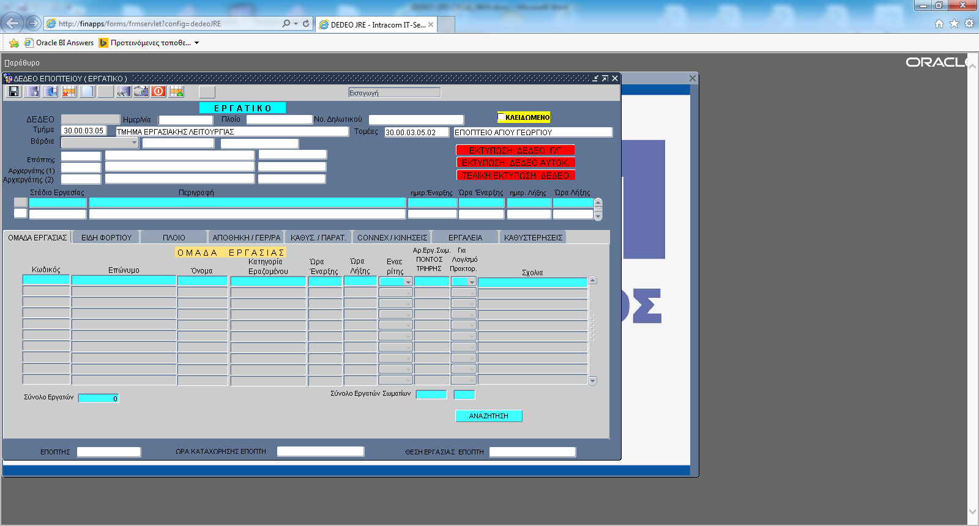
- After inserting the DEDEO then Printing a document and handled it to the supervisor.
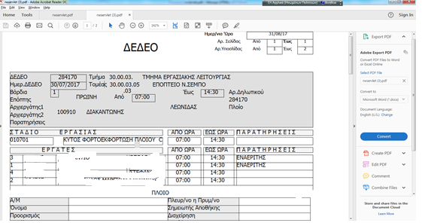
- The supervisor goes to the specified job with the working group which is written on the printing document.
- By the end of the job the supervisor filling the rest of data and completes the printing with all the details that have taken place such as Working Steps (Coded Tasks) with Start and End per Employee, Types of Load and Load characteristics, types of machines to be used for Handling and other characteristics of machinery, also if involved, Ship and its characteristics, crane bridge, CONNEX moves, and its features, Warehouse / Management and its features, tools, delays, etc.
- Then the supervisor provides to completed employment report the workstation’s user.
- The workstation’s user then inserts into the system all the rest information of the specific (worker DEDEO).
- After workstation’s user checking and make the all the corrections then save the (worker DEDEO) into the system.

- After workstation’s user finished with (worker DEDEO) creates the (Supervisor DEDEO) into a different screen, because has no labor productivity like the Worker DEDEO. 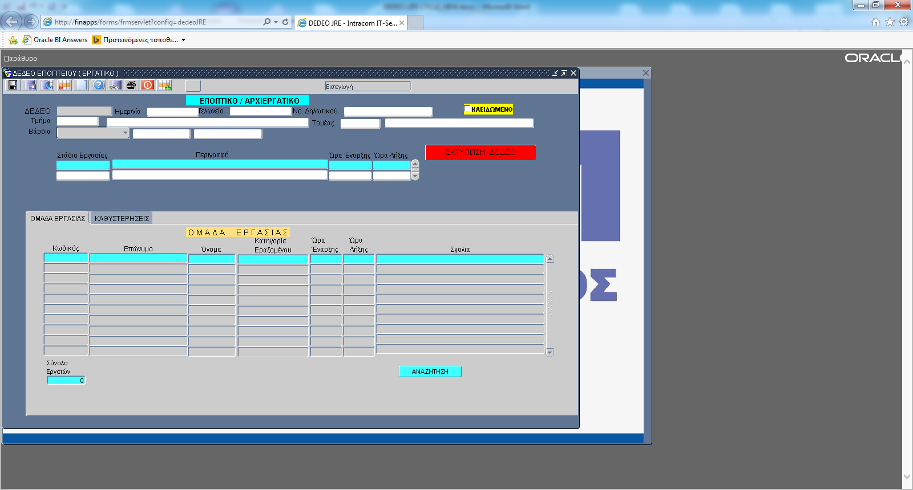
- By end of the the day and more precise by the beginning of the next day (the end of the night shift) the picture of the previous day is completed.
- Transfer DEDEO from the workstation to HR Department / Evaluation Group.
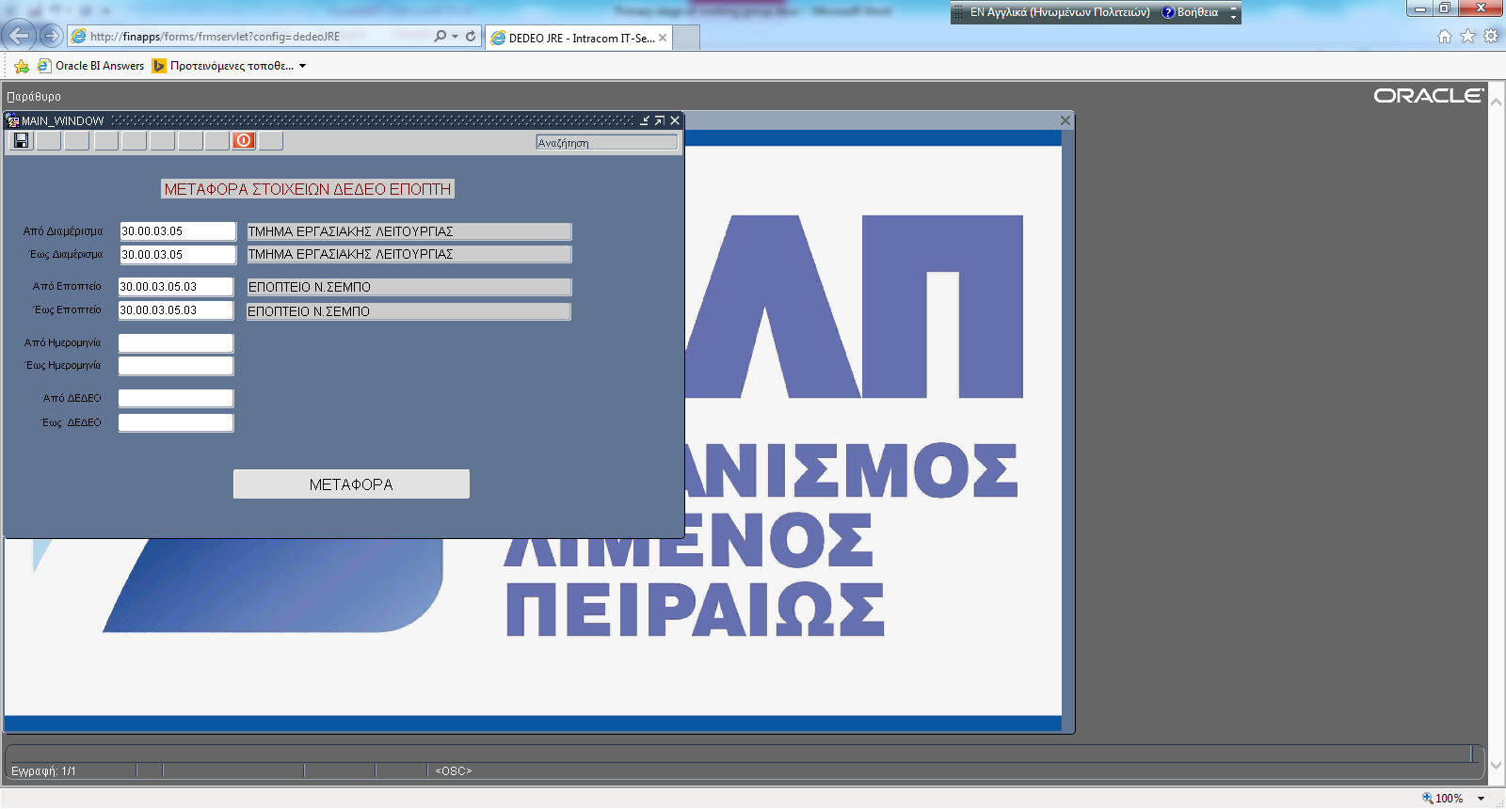
- Automatically the program locks all the transferred rows and no changes are allowed unless it is necessary, unlock the rows and after correction done then the new version is sent to the HR Department / Evaluation Group.
- Checked the transferred DEDEO.
Evaluate the transferred DEDEO by HR Department / Evaluation Group.
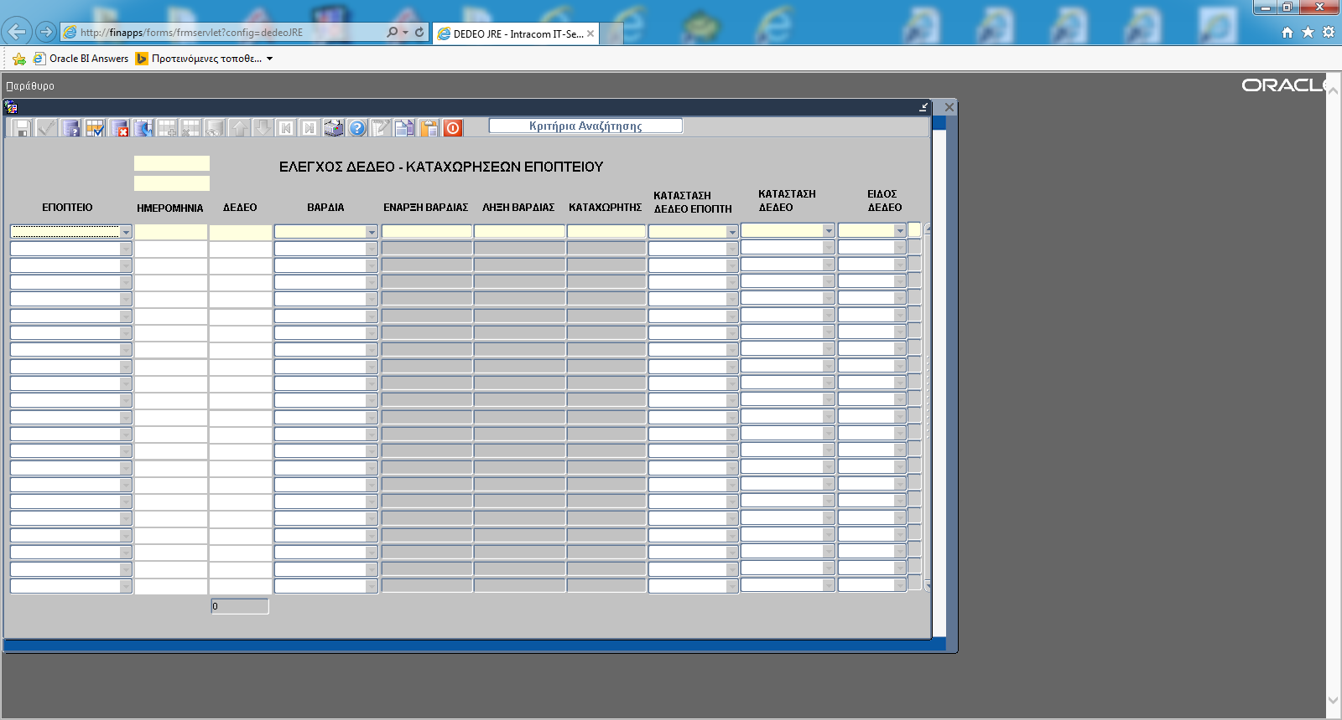

- Run the Valuation Process which is the main process of calculating the wages of the PPA Port workers.
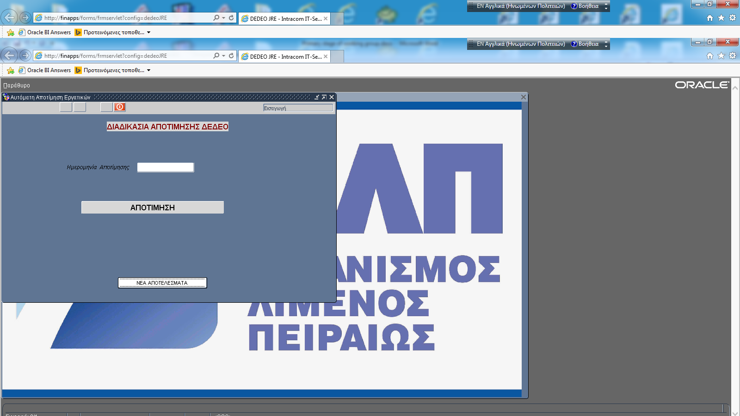
- All the valuing Elements are presented on the Valuation Screen.
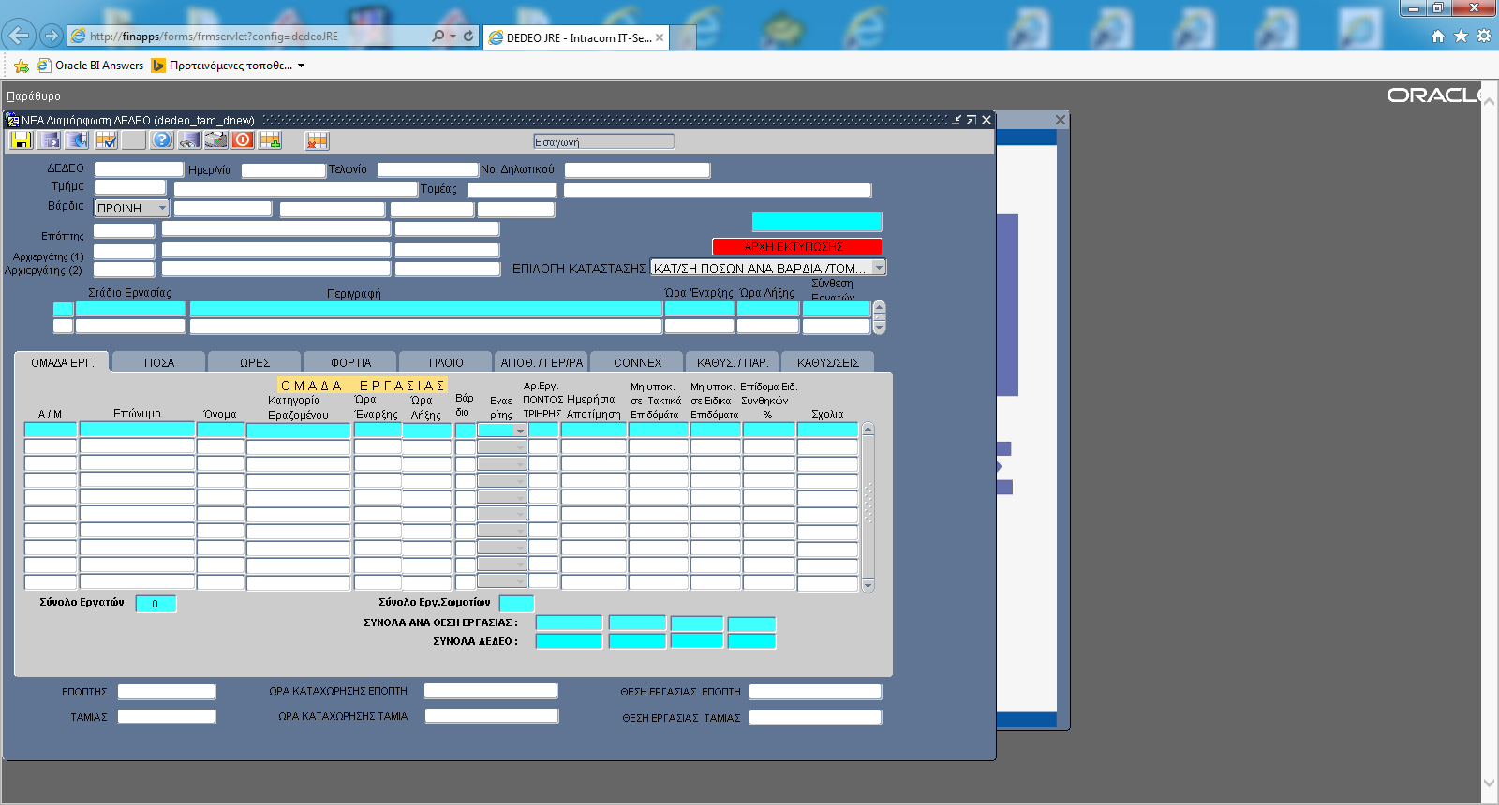
- Then the presented elements are checked by the HR Department / Evaluation Group.
- After the necessary corrections finished by the HR Department / Evaluation Group, then data are ready to be processed by Payroll.
- Then the calculation process of Payroll begins reading all the data from the DEDEO tables and Insert then to the Payroll tables.The Monthly Payroll of PPA Port workers runs in two faces.
A) 15 first days of the month and
B) The rest days of the month with the Monthly Payroll clearance.
DEDEO: Unique entity issued by the PPA Supervision and corresponding to a specific Workgroup, date, time (shift). There are two kinds of DEDEO
- workers DEDEO which consists of dock workers and is subject to an efficient process and labor productivity and
- Supervisors DEDEO which consists only of Supervisors or chief workers who are not subject to an labor productivity.

No | SPECIFICATIONS | REQUIRED | SUPPLIER’S REPLY | REFERENCE
1.1 | Provide maintenance, support, required interfaces and further development if is required in the future of the existing software called “DEDEO”.  The provision of these services will start the same time with the start of the Pilot/Productive Phase of the Project. | YES

4. PAYROLL MODULE

The Payroll module must meet company needs, allowing it to:

1) Manage with complete history all information that is important and necessary to perform a payroll calculation.
2) Organise and manage the rules and information that compose the logic of each payroll calculation.
3) Automatically perform remuneration and Withholdings calculations for a specific and specified each time calendar period in order to determine the Payable Remuneration of the employee, taking into consideration the particularities that apply for each employee.
4) Justify the outcome of the performance of the calculation and diagnose any errors.

PAYROLL TYPES:

- Advance payment of employees (percentage of regular remuneration)
- Advance payment of dock workers (percentage of total half-month remuneration)
- Payroll settlement of Management/Employees/workers/TEI/OAED/Self-employed
- Overtimes calculated for payroll
- Management of travel expenses
- Compensation of Boards/Committees
- Easter/Christmas bonus
- Leave allowance
- Compensation for leave not taken
- Quarterly remuneration
- Issue of payroll tests for employees
- Calculation of bonuses for staff
- Compensation and settlement of pensioner employees/workers

No | SPECIFICATIONS | MANDATORY REQUIREMENT | SUPPLIER’S REPLY | REFERENCE
 | INTEGRATED PAYROLL SYSTEM
1. | DETAILED SPECIFICATIONS
1.1 | Payroll Management Payments (Individual Contracts), Payments of Board Members (Non-Mandate), Managers, Employees Paid on the basis of the Collective Agreement, Employees Paid on Individual Contracts, Workers of Wage and Salary Workers, paid on the basis of each current Workers' Associations, Supervisors / Primary Workers who are paid on the basis of the current CCP Supervisors / Homeworkers, Self-Employed (Individual Contracts). | YES
1.2 | Tracking of payroll of TEI, EPAS, OAED, and Community Service. | YES
1.3 | Automatic calculation of salaries and wages, additional work, overtime, night, Sundays, Holidays, Sunday/Holiday nights, days off | YES
1.4 | Automatic calculation of Bonuses (with calendar days), leave allowance and Redundancy compensation, for all types of employees (employees, day and hourly wage workers, full and part-time, with changes of status midway, compensation provisions, etc.) | YES
1.5 | Automatic granting of steps-seniority premiums, based on the valid Collective Agreement. | YES
1.6 | Option for calculation of back pay of employees, with automatic use of all historical information entered in the database for changes that affect each of the calculation dimensions. Back pay may be either settled with other calculations or set off at printout and file level. | YES
1.7 | Calculation of pregnancy, sick leave days and corresponding allowance. | YES
1.8 | Automatic calculation of leave and leave allowance and closing with regular in its month and vice-versa. | YES
1.9 | Automatic entry of leave and leave allowance not taken and calculation thereof during the employee’s departure | YES
1.10 | Automatic calculation of redundancy compensation and compensation due to retiring | YES
1.11 | Full analysis and printout of allocation of back pay (automatic calculation) - premium - balance in the months, and complete analysis of withholdings, overtime/holidays or other remuneration in each month | YES
1.12 | Complete management of part-time employment, rotation and intermittent employment | YES
1.13 | Tracking of loans and calculation of interest, debts, advances, private insurance contributions and their settlement | YES
1.14 | Tracking of contracts and allowances | YES
1.15 | The transactions must show the history of the employee’s details, even if they change | YES
1.16 | Creation of new recruitment contract by the User | YES
1.17 | On line Calculation of Gross amount from Net and automatic calculation and settlement of tax and solidarity contribution | YES
1.18 | On line calculation of employee’s back pay (either due to change of contract or change of contributions/insurance fund ceiling or due to specialization or grade change etc) | YES
1.19 | Payroll parameters (e.g. Classes, scales, etc.) per year, which means that we have full overview of what used to apply and what currently applies, what has changed from one year to another | YES
1.20 | Scenarios for mass redundancies or increase of remuneration | YES
1.21 | Option for defining different types of calculation of allowances (whether it will be fixed amount, percentage, etc.) | YES
1.22 | Creation of electronic xml payment file for credit of Bank accounts | YES
1.23 | Creation of all files that must be submitted each month to various entities, etc. Overtime file to ERGANI, MTPY loans, Taxisnet, etc. | YES
1.24 | Insurance days calendar. Option for use of calendar for automatic determination of insurance days, either tracking work days or absence days | YES
1.25 | Simultaneous Insurance Contributions per fund (depending on how the fund has defined the contributions, e.g. of TSMEDE) | YES
1.26 | Complete accounting plan in the Payroll article with analysis into regular and extraordinary remuneration | YES
1.27 | Issue of analytical accounting article and automatic update of General Accounting | YES
1.28 | Payroll Accounting article per cost center. | YES
1.29 | Check of non-entered movements  Issues of changes that have passed over a certain period and blocked after agreement with the primary data so that they do not reappear in a subsequent re-check of changes. | YES
1.30 | Option for Imputed Insurance Contributions with automatic link to insurance classes (ceiling). We can also define our own imputed amount (either day wage or salary) | YES
1.31 | Option for tracking regular leave, social leave (election, student, parental, etc.), unpaid leave, etc., in relation to payroll. | YES
1.32 | Link of payroll to the time attendance system with automatic update of movements | YES
1.33 | Tracking of employee occupation per cost position and work sectors (organisational units).  Daily entry of employees occupied, even for certain hours, at cost positions and/or work sectors other than those they belong to. The procedure described above pertains only to the employees, because as regards workers, their occupation per cost positions and work sectors will be tracked through the Automatic Assessment of Labour Day Wages (DEDEO), will be transferred to the monthly Payroll records and updated with additional regular / special allowances, following the rules for calculating these allowances. | YES
1.34 | Procedure for automatic creation of debt (alimony, tax debts, etc.) with fixed amount and instalments number or percentage of total monthly remuneration or combination of the above, with parallel control of due balance in all cases, in order to have automatic expiry. | YES

1.35 |  | Creation of form of entry of primary data pertaining to the calculation of the crane allowance, in order to then calculate the total due amount for the current year, which will be allocated to the corresponding workers, after the necessary withholdings-tax. The calculation is included in the settlement of December of the current year, in order to charge this remuneration to the current year. |  | YES
1.36 |  | Automatic monthly procedure of uploading data through excel files to the payroll tables, e.g. Hellenic PostBank loans, private company contributions, etc., in order to withhold them during payroll settlement |  | YES
1.37 |  | Full Technical documentation of the calculation of employee payroll amounts so as to make the calculation rules distinct and to facilitate the control of amounts |  | YES
1.38 |  | Monitoring of PPA loans to employees with the possibility of receiving more than one loan, without having paid the previous one
2 |  | ANALYTICAL PERIODIC STATEMENT
2.1 |  | Management of IKA (Social Insurance Institute) APS  (regular/supplementary/amending), and printings of them |  | YES
2.2 |  | Automatic creation of APS file for submission to IKA |  | YES
2.3 |  | Automatic creation  of supplementary/amending APS for submission to IKA and printings of them |  | YES
2.4 |  | Multiple choices at the APS such as selecting desired months, types of remuneration per month and specific employees |  | YES
2.5 |  | Option for APS check which we run through payroll |  | YES
2.6 |  | Printout of employer’s certificate through the APS |  | YES
2.7 |  | Automatic control of correctness of Coverage Package in relation to the Activity Code Number (KAD) and the Specialisation Code from IKA’s OSYK (Code Connection Guide) |  | YES
2.8 |  | Prepared table with OSYK special insurance cases |  | YES
3 |  | SALARIED SERVICES TAX (FMY)
3.1 |  | Monthly calculation of withheld FMY, special Solid. Contribution and their annual reconciliation. |  | YES
3.2 |  | Automatic inclusion of employee to untaxed bracket depending on age and children. |  | YES
3.3 |  | Printout of temporary and final payroll taxes (FMY) statement. |  | YES
3.4 |  |  | Entry of manual employee amounts to the annual tax file. | YES
3.5 |  |  | Calculation of PPA SA loans and additional to the annual tax file in the form of a benefit | YES
3.6 |  |  | Procedure for submission of annual tax file to TAXISNET and ability to process the Tax File through an administration form. | YES
3.7 |  |  | Process through administration form, payment codes, payroll records, historical validity (from date to date)
4 |  |  | PRINTOUTS
4.1 |  |  | Summary & analytical statements and payroll files, remuneration/insurance with holdings/debts/taxes/loans, overtimes etc., which can be saved also at xls files. | YES
4.2 |  |  | File bridges through printing. The application must automatically refer to the employee’s file and the payroll transaction through which this printout originated | YES
4.3 |  |  | Printout of Mass Notification of Recruitments-Redundancies | YES
4.4 |  |  | Specified printouts of Transaction and Employee files, reports, statistical data, etc. | YES
4.5 |  |  | Export of all printouts without change of year, in other file formats, excel, word, pdf, and sending them directly in an e-mail | YES
4.6 |  |  | Option for printout of list of employees with a term contract, with the dates on which their contracts end. Alert appear for informing the user. | YES
4.7 |  |  | Printout of advance and settlement receipts (final and temporary) and possibility of sending them to the employees’ emails. | YES
4.8 |  |  | Printout of insurance fund statements, monthly clearance statements, tax certificates, allowances, advance payment, loans-debts | YES
4.9 |  |  | Printout of sick leave of employees with sick leave days they are entitled to per year, and the days they used during the year, with option for calculation of sick pay | YES
4.10 |  |  | Printouts per payroll type, e.g. Management, employees, workers, EPAS/TE, Administration Board members etc. | YES
4.11 |  |  | Total printout of payroll changes per month | YES
4.12 |  |  | Staff Employment Report, in combination with Time Attendance | YES
4.13 |  |  | Individual Payroll Status analytically per employee | YES
4.14 |  |  | Analytical statement of employee remuneration with regular/allowances and extraordinary remuneration/overtime/holidays. | YES
4.15 |  |  | Analytical statement of overtime (hours and remuneration) analytically for all types of overtime/holidays of employees. | YES
4.16 |  |  | Parametric issue of statistics pertaining to staff data (workforce, specialisations, age, time of service, gender, etc.) The data may be drawn according to date, Division, department and for the entire Authority. | YES
4.17 |  |  | Issue of employee employment status per cost position and work sector for a specific date. | YES
4.18 |  |  | Printout of payment orders in English | YES
4.19 |  |  | Printout of payroll statements in English | YES
4.20 |  |  | Printouts of cost per cost center, and remuneration type | YES
5 |  |  | ADDITIONAL REQUIREMENTS
5.1 |  |  | The system must be updated according to labour legislation. | YES
5.2 |  |  | The program must include the most important internet Links (EFKA, OSYK, Contracts, FAQ). | YES
5.3 |  |  | Option for mass identification of employees (that their data are correct compared to IKA’s data) | YES
5.4 |  |  | Monthly update of employer’s obligations | YES
5.5 |  |  | On line help for filling in the fields of each form | YES
5.6 |  |  | Detailed help with frequently asked questions | YES
5.7 |  |  | Management of collective labour agreements. Automation of update and assurance of history of values and rules of payroll calculations. Operator’s information with texts referring to the collective agreement terms. | YES
5.8 |  |  | Allocation of work cost to cost centres and update of General and Analytical Accounting with entries of these values. It must calculate the cost of one employee per cost centre, per payroll period and remuneration type. There are also employees, e.g. electricians, plumbers, whose cost must be entered per day, with start and end times, possibly with the help of time attendance.  Some employees daily working hours cost must split to different cost centres, based on the work. | YES
6. Payroll Interconnection with General Accounting and Analytical Accounting
6.1 | Automated process of creating (Accounting) Payroll articles in General Accounting |  |  | YES
6.2 | Automated Process for Analyzing Cost Centers Accounts for Analytical Accounting for Payroll Costs to be Transported Directly |  |  | YES
6.3 | Interconnection of work performed by employees on behalf of other departments, with the corresponding Payroll Accounts of the other Departments |  |  | YES
6.4 | Parametric introduction of Payroll Cost allocation rules |  |  | YES

5. GENERAL SPECIFICATIONS
No | SPECIFICATIONS | REQUIRED | SUPPLIER’S REPLY | REFERENCE
1.1 | All subsystems must be connected with each other, and the primary information entered in them must be reused to meet the needs of all subsystems. | YES
1.2 | The information system must comply at all times with labour legislation. When it changes, the information system must be correspondingly modified to meet the new legislative regulations. If a new version must be issued, it must always be lawful. | YES
1.3 | It must have a report generator, through which the authorised user can create new reports, OLAP, labels, queries and the possibility to request Customized Reports with information according to PPA/ HR needs included in the agreed value for employment for 2 person days for work relating to data collection. | YES
1.4 | Prior experience in similar projects. | YES
1.5 | Document exchange by email | YES

6. SYSTEM SECURITY

No | SPECIFICATIONS | REQUIRED | SUPPLIER’S REPLY | REFERENCE
1.1 | The information system must have a single user authorisation subsystem. Specifically:  - User rights for each subsystem, for each entity (input, deletion, change, form display, list display, tree display, facets), even at field level (display and change), functions, processes, entry forms, print outs  - User groups (users / administrators / security administrators, positive / negative logic)  - Audit control (open list, open form, selection on the application menu or tool bars, task item execution, MIS execution)  - Privilege management recording  - Single Sign-On capability. The user can login to the application without having to enter credentials.  - Account locking after consecutive failed login attempts  - Option for assignment of more than one roles to the same user  - Mandatory Complexity of password (letters, numbers, symbols, etc.) and notification of users for its change from time to time  - Printouts of role, user rights  - Printouts of users per role | YES

7. INTERNAL AUDIT
No | SPECIFICATIONS | REQUIRED | SUPPLIER’S REPLY | REFERENCE
1.1 | - The system must record user actions, and be able to display in a form the application’s administrator, the user and the time. The actions that can be recorded are: opening of scroller, called aspect and its parameters, tab opening, menu selection, selection from toolbars, task item execution and parameters, MIS execution (printing, OLAP, etc.) and its parameters, etc.  - The administrator’s actions for privilege management must be recorded, such as user creation, privilege assignment to a user group, etc. These entries cannot be deleted. | OPTIONAL
1.2 | - Full history of payroll data, employee’s registry data and transactions.  - Full history of all data that can affect payroll (e.g. overtime, absences, sick leave, etc)  - Keeping last update on all fields of the application. | YES

8. INTERFACES
No | SPECIFICATIONS | REQUIRED | SUPPLIER’S REPLY | REFERENCE
1.1 | Creation of interfaces for communication of the HRMS system with other PPA SA information systems, for automatic exchange of data needed for the smooth operation of the entire information system.  Specifically:  - Interface between HRMS and ERP-ORAMA, through which data of the employees’ register, such as name, shift, absences, Division/department/crew/supervisory, etc., will be automatically transferred.  - Interface between HRMA and ERP-ORAMA for transfer of accounting articles to Analytical and General Accounting  - Interface between the HRMA and the PLAMS machinery maintenance subsystem for transfer of data of employees participating in the task orders and their costing data, e.g. name, hourly wage, overtime cost, etc.  - Time & Attendance must in the future integrate with access control system, that PPA will procure  - HRMS must send absences to HRM software that of PPA  - HRMS must can read day offs from HRM  - HRMS must send and receive overtimes to and from HRM software of PPA  - HRMS must send the changes of employees registry to HRM software  - Payroll must read daily wages of dockworkers from DEDEO  - HRMS must send absences to DEDEO  - HPMS must send the changes of employees registry to DEDEO  - Any other considered mandatory from the analysis | YES

9. TEST SCENARIOS – TEST RESULTS

No | SPECIFICATIONS | REQUIRED | SUPPLIER’S REPLY | REFERENCE
 | Tests
1.1 | To ascertain that the project fully meets the requirements of the specifications and the purposes it was created for, checks of the applications software will be performed.  The Contractor, upon completion of delivery and installation of the applications software, must deliver the system fully and thoroughly checked. In order to meet this obligation, the Contractor must cooperate with PPA SA and implement methodology at integrated system level, supervise the checks and document their results.  The methodology to be used by the Contractor will not differ from that which it must present in its offer.  The methodology phases must include at minimum:  - Scheduling of the check  - Completion of the check  Documentation of the check | YES
1.2 | - All check scenarios, which must cover all functional areas, will be planned by the project contractor, after they are first approved by PPA SA. They will be implemented with the participation of users, on PPA SA’s side. The Contractor must submit to PPA SA the final check scenarios for approval at the latest three (3) months after signing the contract. PPA SA must approve the check scenarios at the latest four (4) months after signing the contract.  - The checks must be completed by the contractor five (5) months at most after signing the contract.  - Successful conduct of these checks is a prerequisite for the launch of the pilot operation period. Within one (1) month after completion of the checks by the Contractor, PPA SA must study the result and decide whether the checks were successful, allowing the launch of the pilot operation period.  - If the checks fail, the Contractor must make the necessary improvements, in order to repeat all the necessary checks related to the change made, until they produce the desired outcome. Any delays caused will affect the start of the pilot operation period and the time of project delivery.  - The check scenario delivery time must be indicated in the project implementation schedule. | YES

10. DATA MIGRATION

No | SPECIFICATIONS | REQUIRED | SUPPLIER’S REPLY | REFERENCE
1.1 | Before the start of the pilot operation, the data considered critical for the system’s operation must be entered into the system, according to the Migration Plan prepared in communication with the competent staff and competent PPA SA committee. Presence of these data on the Information System is deemed necessary for the substantial control of the system's operation and the on-the-job training of users. The Contractor, according to the migration plan delivered, must provide for relevant procedures and offer to PPA SA the appropriate standards, in order to prepare in the most effective manner the files to be migrated to the HRMS.  The Contractor must guide and support the migration and input of the existing PPA SA files on the new system during its pilot operation. As regards physical files, the Contractor, according to the migration plan to be delivered, must offer the suitable templates to PPA SA, which will allow its departments to fill in these templates in the most efficient manner, based to the data of the physical files.  The Contractor must guide and support the migration and input of the existing PPA SA files on the new system during its pilot operation. | YES
1.2 | Migration of historic payroll data from the existing Payroll software to new one for reporting reasons | YES

11. TRAINING

No | SPECIFICATIONS | REQUIRED | SUPPLIER’S REPLY | REFERENCE
1.1 | The candidate must submit a “Training Plan” before the training phase of the project, which will aim at the transfer of know-how to the PPA SA members, allowing them to:  - Understand the functions of the applications, systems and accompanying administration tools  - Gain practical experience in the use of manuals and other help materials required for the installation, maintenance, management and seamless operation of the HRMS.  - Gain practical experience depending on the role they will play in the HRMS operation. | YES
1.2 | Overall, the contractor must offer adequate training for the staff to be indicated by PPA SA. It is important for the candidate to submit a training program that will coincide with the delivery schedule. The training must be completed up to the final acceptance of the information system. | YES
1.3 | PPA SA, in cooperation with the Contractor, may modify the training program (e.g. number of trainees, number of courses, training duration, organisation of groups), depending on the needs, in order to better meet the goals that have been set. | YES
1.4 | Training of key users and administrators, pertaining to the complete transfer of know-how to an adequate core of members of each involved operational unit (key uses and management executives), who will undertake the development of the suitable skills of all users of the new information system, in order to support the procedure of full entry into productive operation. | YES
1.5 | Transfer of know-how and development of skills in a select group of PPA SA members, pertaining to a Group of IT and HR members formed by PPA SA, who will then undertake the productive operation of the new system (administration, maintenance) and will play a key role in the support of the other users. | YES
1.6 | On-the-job training, pertaining to the additional training of users of the applications on the job, which the contractor that will develop the applications will provide, addressing any concerns and questions of the users. It is part of the training and an integral part of the support services to be offered by the Contractor. | YES
1.7 | The Contractor must mention in the Training Plan the title, purpose, content and duration of each proposed training module, separately for each part of the HRMS, such as the application software (distinctness per subsystem).  The Contractor must provide a time schedule for the training program, showing the proposed succession of the courses, the staff categories each course is addressed to, and the training hours per application. | YES
1.8 | All trainings will take place in the Greek language and in a suitably arranged space inside PPA SA and will be accompanied by detail training material. | YES

12. TECHNICAL SPECIFICATIONS OF THE SOFTWARE

No | SPECIFICATIONS | REQUIRED | SUPPLIER’S REPLY | REFERENCE
1.1 | Full and analytical description of the architectures of the HRMS integrated system. | YES
1.2 | The systems to be installed will have state-of-the-art technology and open architecture, namely they will provide independence from any specific supplier and will use standards that will ensure:  - Seamless cooperation and operation between the separate functional applications and systems of the integrated solution,  - Network cooperation between applications and/or systems located on different computer systems,  - Expandability of IT systems and applications without changes to their structure and architecture.  d) Extensions of the software that will be required to be implemented in the future, will be implemented in such a way that they do not prevent or hamper future upgrades of the core of the software. | YES
1.3 | Open architecture will be used at software application level (e.g. Modular design, functionality extension, APIs, etc.). | YES
1.4 | The provided HRMS software must necessarily be based on open standards and Application Programming Interface (API), which allows full access to its services. The API must be documented and be provided with out-of-the-box functionality. | YES
1.5 | Moreover, the system’s modular architecture is required, to allow future extension and replacements, integrations, upgrades or changes of distinct software parts. The system will have at least 3-tier architecture for flexibility of cost allocation between central systems and work stations, for efficient use of the network and easy expandability. | YES
1.6 | Refer in detail to the minimum and recommended requirements for Hardware Database Server - Application File Server -Web Server - work stations and Software (Operating System, RDBMS) | YES
1.7 | Describe the ideal topology of the servers to be used in the installation of the HRMS system | YES
1.8 | RDBMS: required to be compliant Oracle 11G R2 and Oracle 11G R2 RAC or 12c | YES
1.9 | The Contractor will use relational database management systems (RDBMS) for easy handling of large volumes of data, creation of user-friendly applications and the system’s increased availability. | YES
1.10 | The application development environment must be based on international standards and protocols. | YES
1.11 | Open documented and published interface systems with third-party programmes | YES
1.12 | Open communication protocols. | YES
1.13 | Open environment in terms of transfer and exchange of data with other systems. | YES
1.14 | Option for export of all reports and system statistics in different electronic file formats for their best utilisation in each case (e.g. Webpages, simple text, PDF documents, Word/Excel documents, relational tables, etc.). | YES
1.15 | State the upgrade and new version policy of the offered system. Is required to provide new versions of the software based to technological changes. | YES
1.16 | If the provided software requires the usage of a licensable application server software, the required licenses must be provided as a part of the offer. | YES

ANNEX B: FINANCIAL PROPOSAL SUBMISSION FORMS
________________[ Date]
To:
______________________________________ ______________________________________ ______________________________________
[Name and address of PPA]

Ladies/Gentlemen:
We, the undersigned, offer [ ………………….] in accordance with your Call entitled “PPA S.A. CALL OF TENDER FOR THE AWARD OF PROCUREMENT OF ………………….” dated (__________________) [Date] and our Offer. Our attached Financial Proposal is for the sum of Euros (_________________________________________________________________) [Amount in words and figures] and is our full and final offer that does not include VAT.
Our Offer shall be valid and binding (without any terms) vis-à-vis PPA for four (4) months after the expiry of submission date of the offers according to the tender terms.
We understand you are not bound to accept any Proposal you receive and that we will not be entitled to receive any additional compensation for our proposal and that we will not have a right of renegotiation or reconsideration of this amount.
Yours sincerely,
_____________________________ [Authorized Signature]
_____________________ [Name and Title of Signatory]:
_______________________ [Name of Firm]
______________________ [Address]

ANNEX C: FINANCIAL OFFER TABLES

- Software
Α/Α | DESCRIPTION | ITEM NAME | QUANTITY | PRICE [€]  Excluding VAT |  | VAT [€] | TOTAL PRICE INCLUDING VAT [€] | * MAINTENANCE COST [€]  EXCLUDING VAT
 |  |  |  | UNIT PRICE | TOTAL PRICE | VAT [€] | TOTAL PRICE INCLUDING VAT [€] | Year 1 | Year 2 | Year 3
 |  |  |  | TOTAL | Β |  |  | Β1 | Β2 | Β3

* Maintenance Cost refers to the years after the end of the minimum 2 Years requested Warranty period.

- Implementation Services (Design – Installation – Configuration – Migration – Commissioning). As described in the Technical document
Α/Α | DESCRIPTION | Man Month | PRICE [€]  Excluding VAT |  | VAT [€] | TOTAL PRICE INCLUDING VAT [€]
Α/Α | DESCRIPTION | Man Month | UNIT PRICE | TOTAL PRICE | VAT [€] | TOTAL PRICE INCLUDING VAT [€]
TOTAL
- Other costs
Α/Α | DESCRIPTION | Man Month | PRICE [€]  Excluding VAT |  | VAT [€] | TOTAL PRICE INCLUDING VAT [€]
Α/Α | DESCRIPTION | Man Month | UNIT PRICE | TOTAL PRICE | VAT [€] | TOTAL PRICE INCLUDING VAT [€]
TOTAL

- Operational Support during of Productive Operation

Α/Α | DESCRIPTION | Man Month | PRICE [€]  Excluding VAT |  | VAT [€] | TOTAL PRICE INCLUDING VAT [€]
Α/Α | DESCRIPTION | Man Month | UNIT PRICE | TOTAL PRICE | VAT [€] | TOTAL PRICE INCLUDING VAT [€]
TOTAL

- Training

Α/Α | DESCRIPTION | Man Month | PRICE [€]  Excluding VAT |  | VAT [€] | TOTAL PRICE INCLUDING VAT [€]
Α/Α | DESCRIPTION | Man Month | UNIT PRICE | TOTAL PRICE | VAT [€] | TOTAL PRICE INCLUDING VAT [€]
ΣΥΝΟΛΟ

- Financial Offer Summary Table
Α/Α | DESCRIPTION | TOTAL PRICE [€]  Excluding VAT | VAT [€] | TOTAL PRICE INCLUDING VAT [€]
1 | Software (Table 1.1)
3 | Implementation Services (Table 1.2)
4 | Other Costs (Table 1.3)
5 | Operational Support Services (Table 1.4)
6 | Training (Table 1.5)
 | GRAND TOTAL

ANNEX d: FORM OF participation TO TENDER BANK GUARANTEE

(TENDER BANK GUARANTEE)

Piraeus Port Authority S.A. (PPA S.A.)
10, Akti Miaouli
185 38, Piraeus Greece
Date: ………………….

Dear Sirs,
1. We have been advised that:
a) [Full Name], a [Type of Entity], lawfully established under the laws of [jurisdiction], with registered offices at [Full Address of Registered Office], registration number [number of corporations’ or similar register], as lawfully represented (the “Candidate”) intends to submit a binding offer (the “Offer”), in response to a document entitled “Call of Tender for the award of procurement of Human Resources Management System (HRMS)”, issued by Piraeus Port Authority S.A. (“PPA” or “you”) and dated …….. April 2018 (the “Call”). Capitalised terms not defined herein shall be used as defined in the Call.

2. We have been advised that the obligations of Candidates regarding their participation in the tender process are several and accept to be bound by and to honor this letter of guarantee whether or not a call on this instrument results from the act or omission of any of the persons named at the beginning of paragraph 3 below.

3. In view of the foregoing and at the request and for the account of the Candidate, we [Full Name of Eligible Bank], acting through our [●] branch of [Full Address], hereby guarantee irrevocably and unreservedly to PPA S.A. for the full and proper observance by, and compliance of the Candidate with the terms and conditions applicable to their participation in the Process, as well as for any and all other financial and non-financial obligations of the Candidate relating to its participation in the Process, each pursuant to Call and the provisions of applicable law, up to a maximum aggregate amount of five thousand Euros (5.000,00 €)

4. We shall commit the above amount and shall pay same to you in whole or in such part as you may specify in writing, without any objection or pretext, within two (2) Athens business days following receipt of your first and simple demand in writing or by authenticated SWIFT making reference to this letter of guarantee and stating that the Candidate(s) failed to comply with the terms
5. We hereby expressly and irrevocably waive the benefit of division and discussion, our right to invoke any of the objections of the prime obligor, including personal and non-personal objections and, in particular, any objection provided for under Articles 852-855, 862-863, 866, 867 and 869 of the Greek Civil Code and waiving also any and all of our rights under the said Articles.

6. No approval, act or consent on the part of any of the Candidates, the applicant(s) hereof or any third party shall be required for payment of any amounts hereunder. In addition, no objection or disagreement of any of the foregoing persons or their eventual recourse to courts of any jurisdiction or arbitral tribunals seeking non forfeiture of this letter of guarantee shall be taken into consideration.

7. Subject to paragraph 8 below, this letter of guarantee is of indefinite duration and in any case shall remain in full force and effect until the earlier of: (a) the date on which all amounts available hereunder have been fully and actually drawn and paid to you; (b) upon receipt of your confirmation in writing or by authenticated SWIFT to the effect that you finally and irrevocably release us from any obligations hereunder.

8. This guarantee shall be governed and construed in accordance with Greek law. The courts of Athens, Greece shall have exclusive jurisdiction to resolve any disputes associated with this instrument.

Respectfully,
For [Eligible Bank]
[Authorized Signatures]

ANNEX E: LETTER OF BANK GUARANTEE FOR THE RETURN OF ADVANCE PAYMENT
PUBLISHER................................................. ......................
Date of issuance ...................
To: Piraeus Port Authority SA
Akti Miaouli 10
185 38 Piraeus
Our Letter of Guarantee No ................ for euro .. .......................
Furthermore, we understand that, according to the conditions of the Contract, an advance payment of 20% of the contract value, i.e. ............................euros, without VAT is to be made against an advance payment guarantee.
Herewith, we guarantee, irrevocably and unconditionally, waiving the right to divide and to require the debtor to pay first, in favor of
{In the case of an individual company: the Company ............... Street ............. Number ....... postcode. .........}
and up to the amount of euro ........................., for the advance payment of the contract with .......... ......... concerning the contract no ............. with the subject ....... ............ .. ...... of total value ......... .........
The above amount of the guarantee is held at your disposal which we are obliged to pay to you in whole without any rejection or objection on our behalf and without considering the merits of your claim within three (3) days upon your written notice.
This guarantee shall come into force on the date on which the account no:…………………………………..of the Principal held with., ………. Branch is credited for the amount of ………. (say:..............)

The present is valid until it is returned to us or until we receive a written statement of yours citing that we can consider our Bank as being free of any obligation. If the guarantee is forfeited, the amount of the forfeiture is subject to the applicable stamp duty.
(Authorized signature)

