Tuesday, 04th September 2018

Piraeus Port Authority S.A.
Procurement Department
10, Akti Miaouli,
GR 185 38,
Piraeus, Greece.
Tel: +30 210 4550189
Fax: +30 210 4550187
E-mail: procurement@olp.gr

Subject: Clarifications to the interested parties, regarding the Call of Tender for the procurement of TYRES for GOTTWALD, in accordance with the attached technical specifications.

Interested parties are kindly requested to refer to all clarifications published provided by PPA, regarding the questions received until 3rd September 2018, in relation to the “Call of Tender for the procurement of TYRES for GOTTWALD”.

Question 1:

Concerning the request for offer for the procurement of tyres for Gottwald we would like you to clarify if you request the specific tyre (VHB***) or you name it for the purpose of showing the specific pattern?
If the second choice is applicable, please indicate if you need a Radial or Bias structure.

Answer 1:

Bias tyres for Container Handling and Industrial use.

Question 2:

Θα θέλαμε να σας ζητήσουμε διευκρινίσεις, σχετικά με τον Διαγωνισμό “Call of Tender for the procurement of Tyres for Gottwald”.

Παρακαλώ πολύ όπως μας στείλετε πλήρη τεχνικά χαρακτηριστικά για τα ελαστικά για το μηχάνημα GOTTWALD type 14-R24 VHB***.

Answer 2:

Για λήψη τεχνικών πληροφοριών , ανατρέξτε στους ακόλουθους πίνακες:

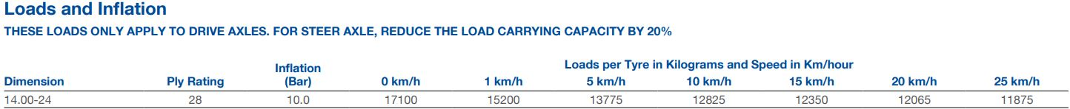

Please visit regularly PPA SA website, in order to be promptly informed about the above mentioned tender.

