Tuesday, 04th September 2018

Piraeus Port Authority S.A.
Procurement Department
10, Akti Miaouli,
GR 185 38,
Piraeus, Greece.
Tel: +30 210 4550189
Fax: +30 210 4550187
E-mail: procurement@olp.gr

Subject: Clarifications to the interested parties, regarding the Call of Tender for the procurement of twenty eight (28) semi-trailers, 65 ton rated loading capacity for terminal tractors (Part III).

Interested parties are kindly requested to refer to all clarifications published provided by PPA, regarding the questions received from 23 August 2018 until 4th September 2018, in relation to the “Call of Tender for the award of Procurement of twenty eight (28) semi-trailers, 65 ton rated loading capacity for terminal tractors”.

The said replies constitute an integral part of the Call.

Question 1:
Please inform if a bidder can submit offers of two different manufacturers and in positive case how should form his offer (files to be submitted etc).

Answer 1:
Each Offer can include only one manufacturer.

Question 2:
According to your requirements, this time it is mentioned within the tender terms that DAP delivery term is requested with complete (assembled) trailer. Since it was difficult to define the price information from Piraeus customs side, i.e. local charge as discharge of the complete trailer, the local custom clearance fees. Therefore please clarify if it possible to alternatively offer CIF + SKD with 45ft container shipping.

Answer 2:
In order to facilitate the process, CIF Container Terminal, Piraeus, Greece can be offered as an alternative. SKD is not acceptable.

Question 3:
Please confirm that all the requested spare parts are:
- 28 tyres including the rim
- Two (2) complete sets of shafts

Answer 3

The requested spare parts are:
- 28 tyres including the rim
- Two (2) complete sets of axles

Please also note that according to page 14 of the call of the tender the following are also requested to be offered:

- One (1) wheel and tyre per semi-trailer.
- Two complete axles in total.
- Any offered special tools concerning the maintenance and repair of semi-trailers.

Question 4:

Please be informed that the 12R22,5 tyres are delivered with 16 tire plies/ fibre cords not with 18 as stated in the tender document, specifying that their operation is not affected at the requested operating speeds.

Answer 4:

According to the specifications of the call of tender (page 24) “ ….The semi-trailer will be equipped, ………….with tyres 12.00Rx22,5 18PR tubeless ….”.

Question 5:

It is assumed that is not required to install a spare tyre compartment on the trailer as you have requested the extra 28 wheels separately.

Answer 5:

It is confirmed that it is not required to install a spare tyre compartment on the trailer.

Question 6:
Please clarify what is meant by “foldable lower part” at the trailer landing legs.

Answer 6:
Landing legs with foldable lower part are those depicted below:

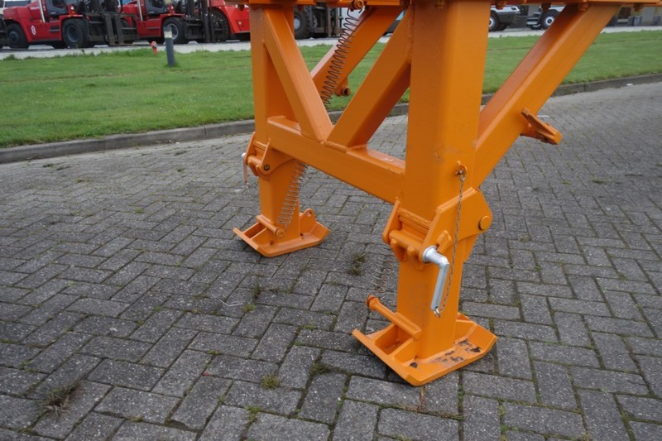

Please visit regularly PPA SA website, in order to be promptly informed about the above mentioned tender.

