02nd October 2020

Piraeus Port Authority S.A.
Procurement Department
10, Akti Miaouli,
GR 185 38,
Piraeus, Greece.
Tel: +30 210 4550186
Fax: +30 210 4550187

Subject: Clarifications, regarding the “Invitation for Procurement of absolute & incremental encoders for the needs of RMG & PP cranes”.

Interested parties are kindly requested to refer to all clarifications published provided by PPA, regarding the questions received until 02 October 2020, in relation to the “Invitation for procurement of absolute & incremental encoders for the needs of RMG & PP”.

The said reply constitute an integral part of the Call.

Question 1:

Item 1: The P/N for the incremental encoder HOG10 D 1024 I 16H7 LR is not complete and its manufacturer Baumer International GmbH cannot identify your item to 100%. The missing part is the suffix related to the type of connection. This may be "KLK" (for terminal box, radial) or "KLK-AX" (for terminal cover, axial). Since you ask for "plug and play" requirements, the position of the terminal must be specified so that new item can fit into position. Please, define the type of connection, alternatively send us the full serial number of the existing device or a photo of the label and the encoder to enable correct identification.

Answer1:

Please find below a photo of the existing device:

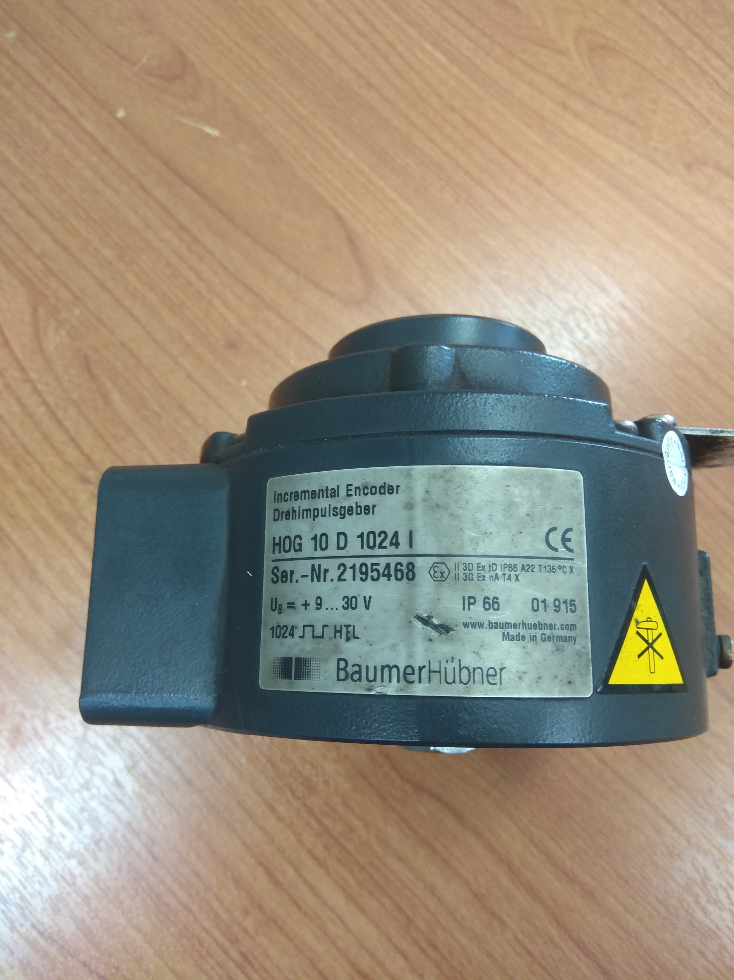

Question 2:

Does the Technical Offer, also, need a password or only the Financial Offer? Moreover, the totality of the offer must be submitted in Greek or in English?

Answer 2:

- According to the Invitation’s requirements each offer should consist of two (2) individual folders: a. the technical offer including any participating documentation needed according to tender terms and b. the financial offer. The two different folders should be protected with separate/different passwords.

- Both languages are acceptable.

Please visit regularly PPA SA website in order to be promptly informed about the above mentioned tender.

