06 October 2020

Piraeus Port Authority S.A.
Procurement Department
10, Akti Miaouli,
GR 185 38,
Piraeus, Greece.
Tel: +30 210 4550186
Fax: +30 210 4550187

Subject: Clarifications, regarding the “Invitation for submitting offers for the procurement of Inverter, Rectifier & Electric motor 55KW for Straddle Carries ESC350 & ESC 350W”.

Interested parties are kindly requested to refer to all clarifications published provided by PPA, regarding the questions received until 06 October 2020, in relation to the “Invitation for submitting offers for the procurement of Inverter, Rectifier & Electric motor 55KW for Straddle Carries ESC350 & ESC 350W”.

The said reply constitute an integral part of the Call.

Question 1:

Regarding the attached invitation of submitting offers, in order to proceed to our relevant submission, we need more information about the requested products. In particular, we would like to know, the full product codes of the requested products and/or relevant datasheets ( photos of the nameplates would ,also, be useful ). ….

Answer 1:

In reply to the requested clarifications, please see the photos below:

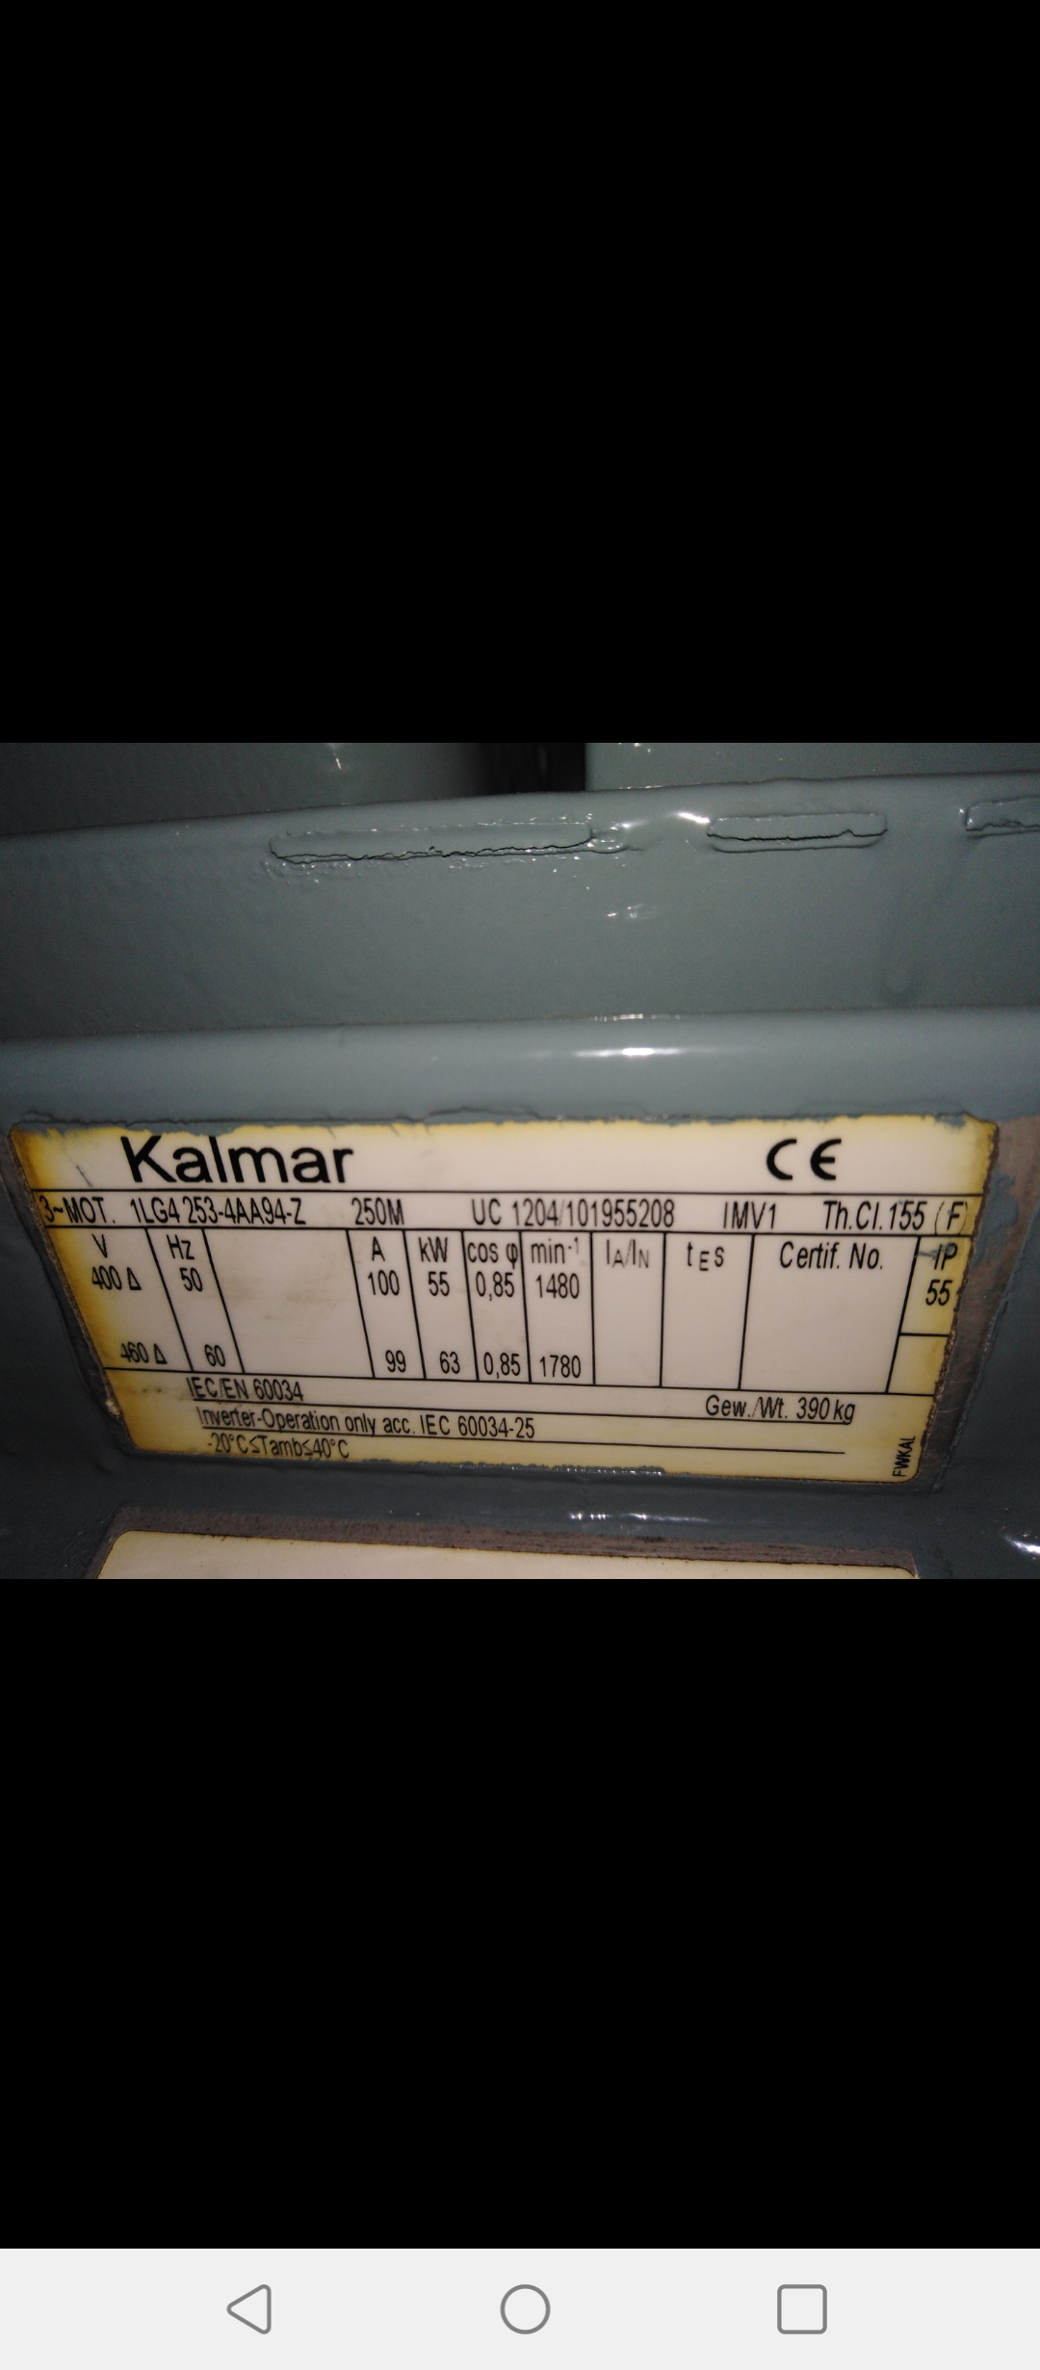

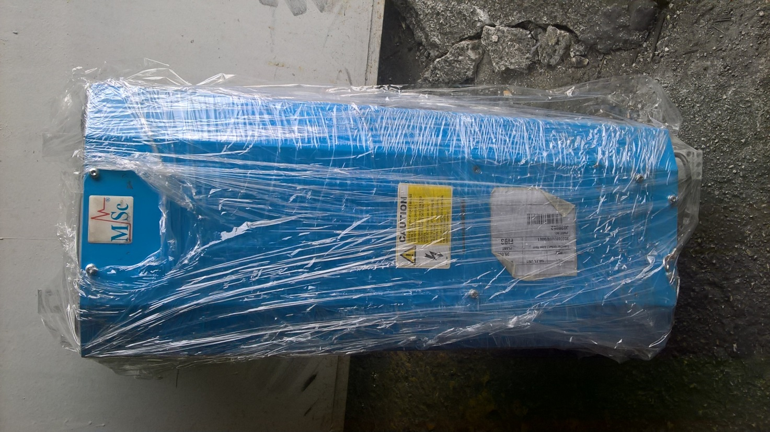

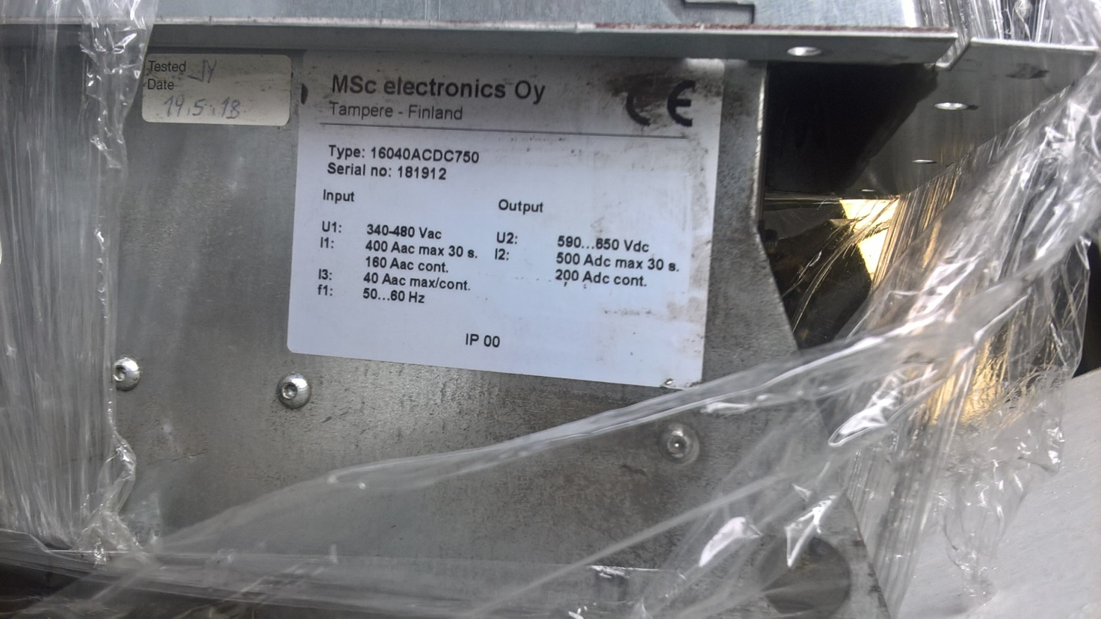
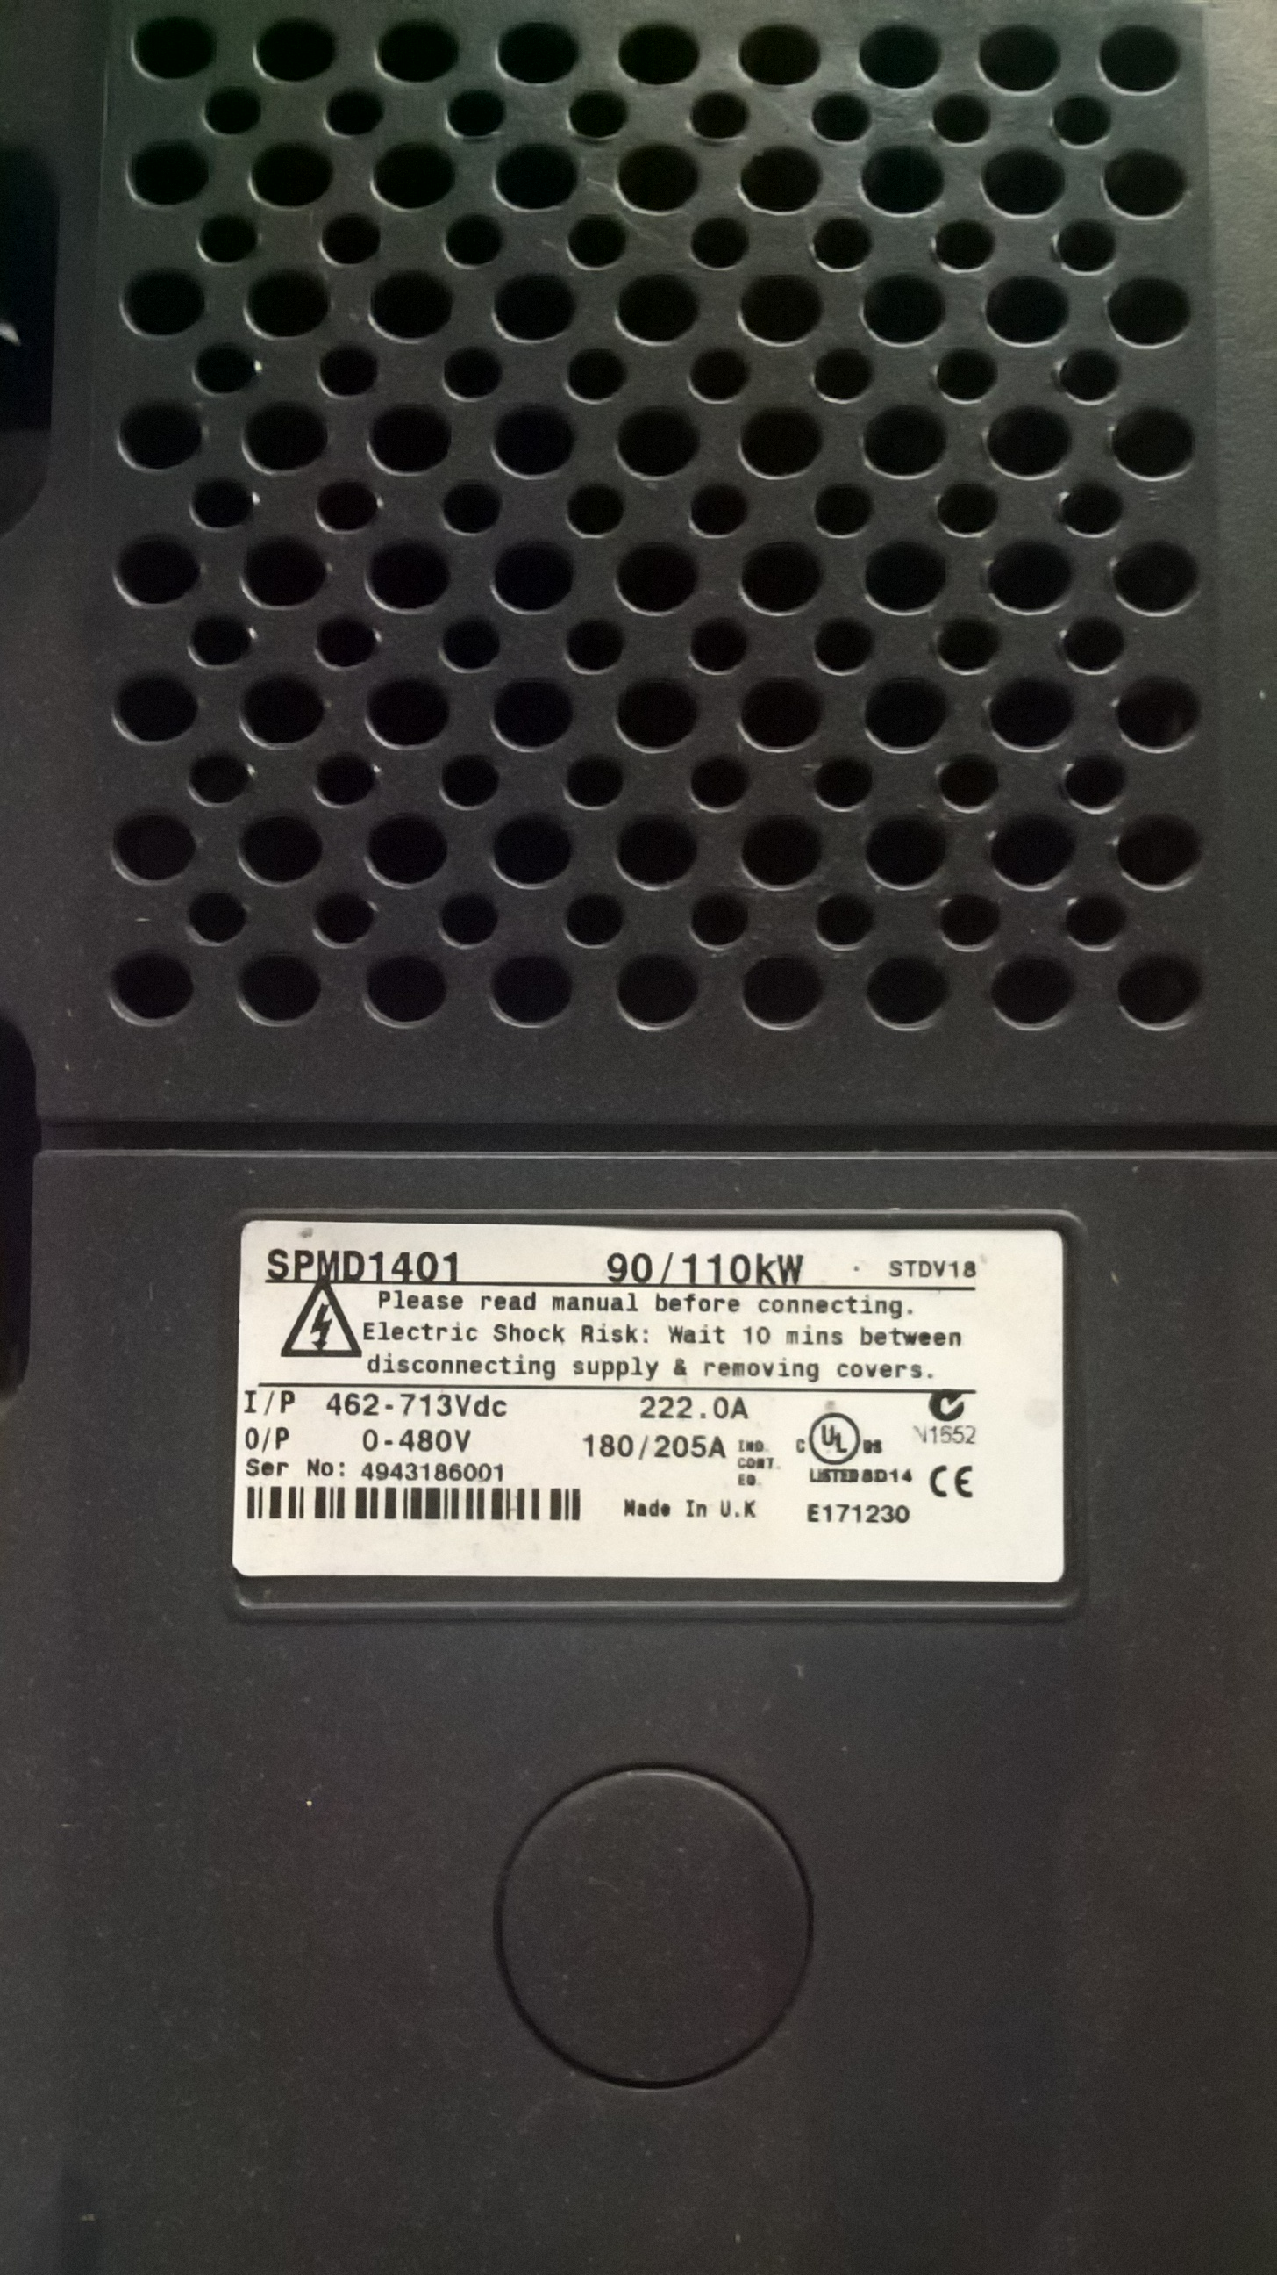
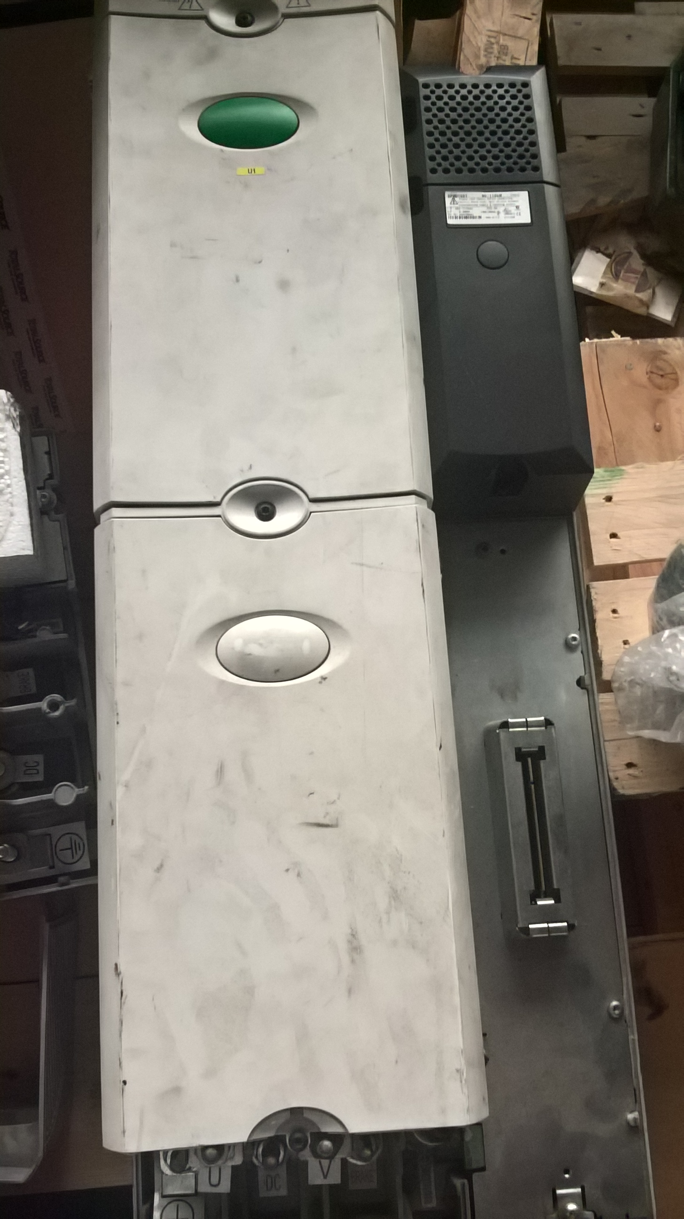
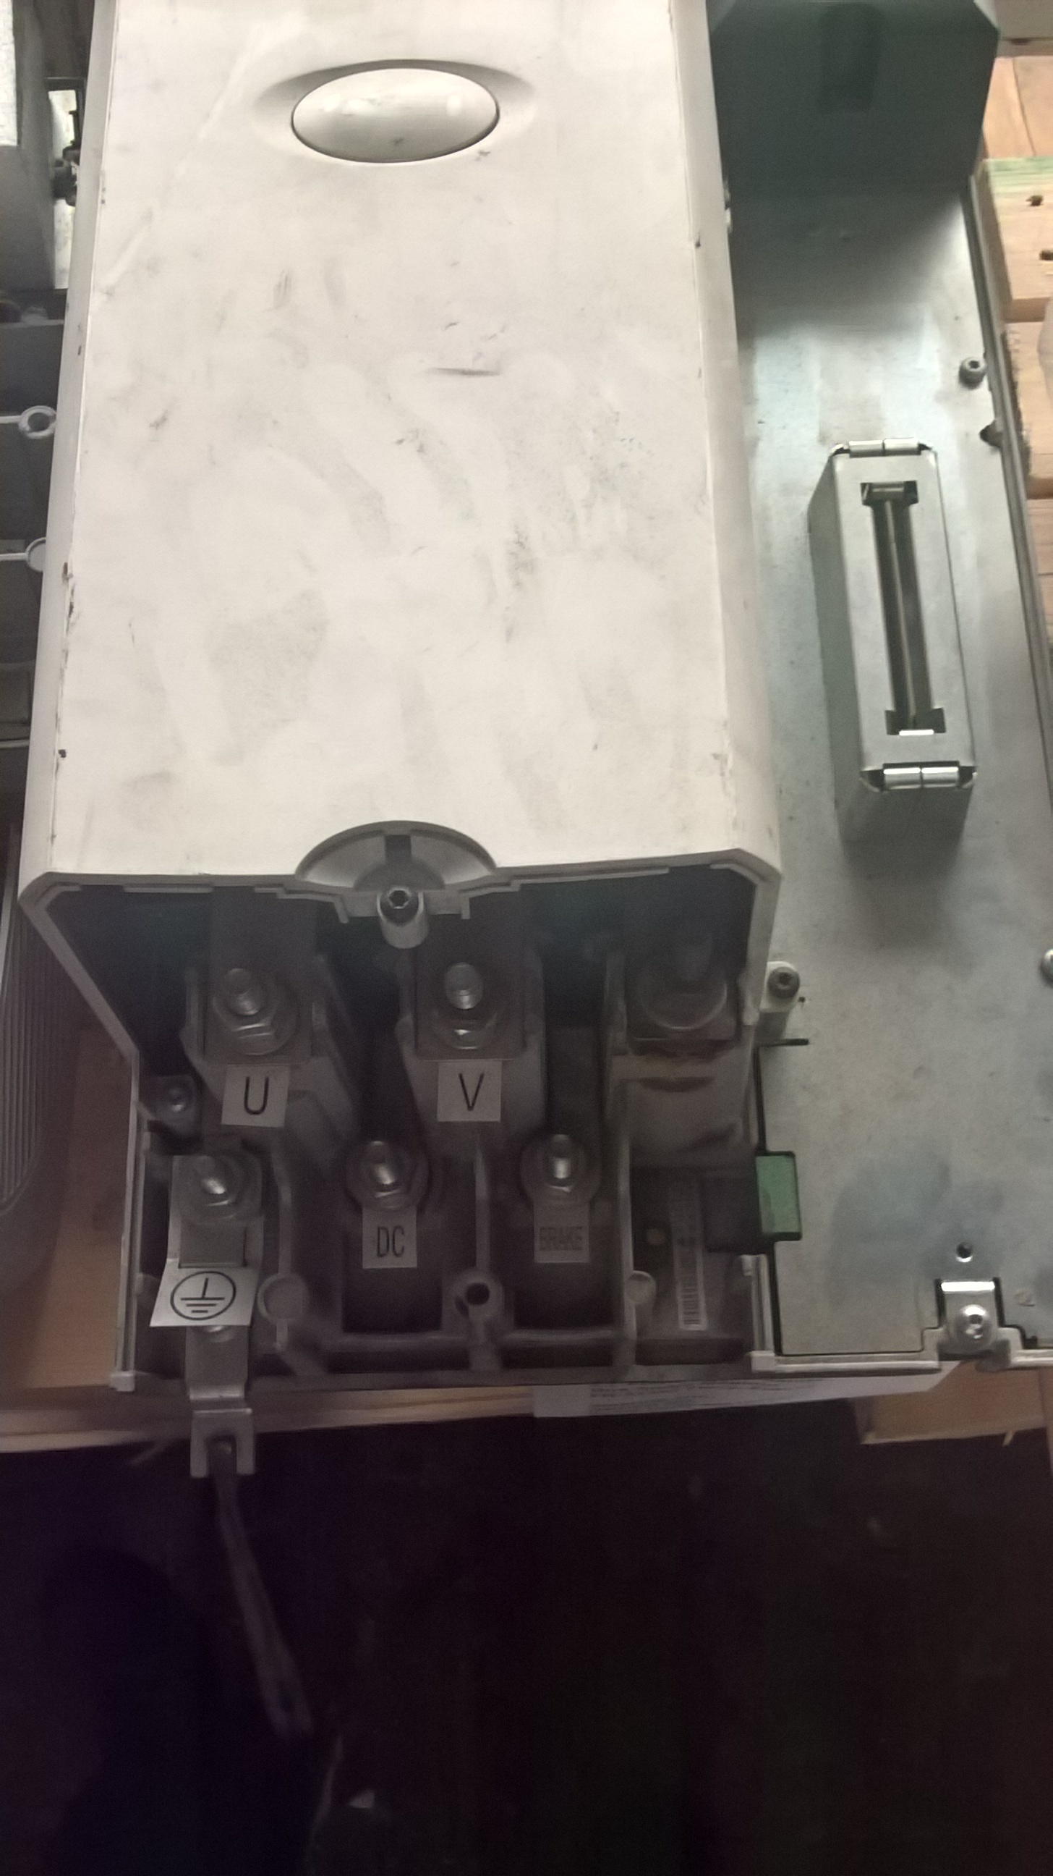

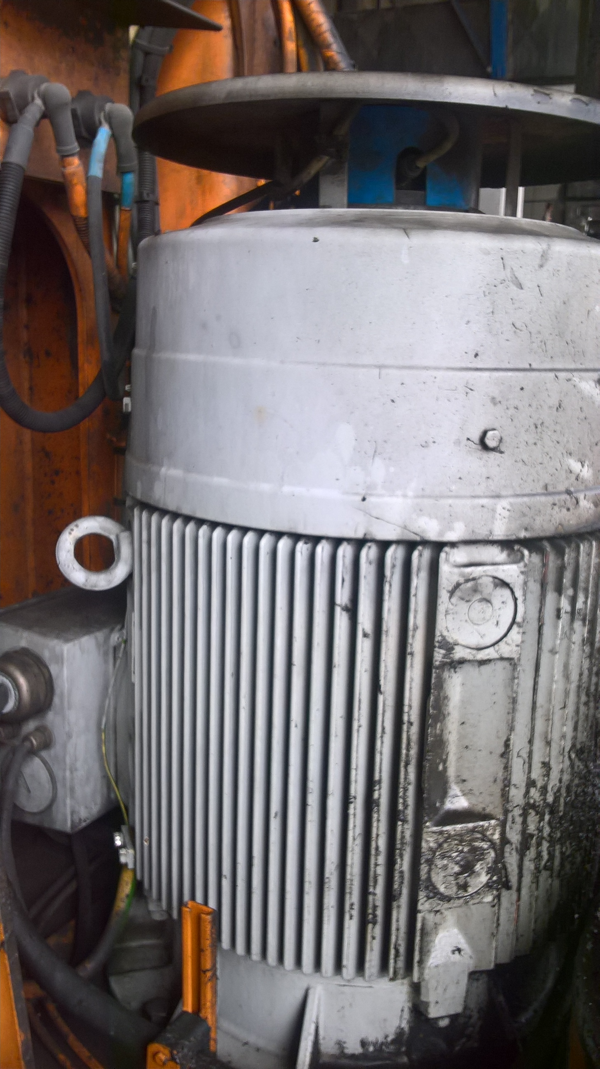

Please visit regularly PPA SA website in order to be promptly informed about the above mentioned
tender.

