22 -12- 2020

Piraeus Port Authority S.A.
Procurement Department
10, Akti Miaouli,
GR 185 38,
Piraeus, Greece.
Tel: +30 210 4550186
Fax: +30 210 4550187

Subject: Clarifications, regarding the “Invitation for procurement of ropes, wire ropes, belts and shackles for Floating & Graving Docks”.

Interested parties are kindly requested to refer to all clarifications published provided by PPA, regarding the questions received until 21/12/2020, in relation to the “Invitation for procurement of ropes, wire ropes, belts and shackles for Floating & Graving Docks”.

The said reply constitutes an integral part of the Call.

Question 1:
Following up with your invitation for the procurement of
equipment for Floating and Graving docks, please advise regarding the following:

- Items 1-4 refer to wire rope slings with pressed loops? – please confirm
- items 12-16 : please advise regarding the WLL per item
- items 20-31 + 44: please advise regarding the type of the shackles a) screw pin b) safety bolt with nut
- item 32: can we offer equivalent material to Crosby master link?
- item 41 : flat or round sling? – please confirm EWL ( effective working length) is 2m
- item 46 : please provide us with additional information for the requested equipment.

Answer 1:

- Items :1-4 we confirm that the wire ropes slings are coming with pressed loops.
- Items :12 = 1.5 t / 13=2t / 14=3t / 15=4t / 16=6t.
- Items : 20-31+44 we need shackles with screw pin.
- Item 32 : Yes.
- Items 41 : we need flat slings 5t.
- Items 46 : two cable grips with eye connection two wire ropes.

Question 2:
Following up with our previous email, please also advise regarding the following details

- items 1-4 : - galvanized or ungalvanized? loop size is for both ends or only one end? other end standard eye size?
- items 5-11: galvanized or ungalvanized?
- items 37-40 + 43 : galvanized or ungalvanized? with soft loops or thimbles? hooks at each end?

Answer 2:
- Items 1-3 : Galvanized , loop size is for both ends ( non-greased ).
- Items 4 : Galvanized , loop size is for one end.
- Items 5-11 : Galvanized.
- Item 37 : Galvanized with soft loops and hooks at each end.
- Items 38-40 : Galvanized, no soft loops , no hooks at each end.
- Items 43 : Galvanized no soft loops , no hooks at each end.

Question 3:
Regarding to the tender attached above, please revert back to our queries and requests.

- Item 12-13-14-15-16. The weight values of the Polyester Sling Belts must be specified separately
- Item 5-6-7-8-9-10-11. Loop-Loop lengths of wire rope slings not specified so ,standard measurement will be considered Standard case=Wire rope diamater x 15 i.e: 15mm x 15 = 225mm
- D-SHACKLES will it be with screw or nut?
- BOW SHACKLES will it be with screw or nut?
- Item 33-34-35-36. Need to know the chain norm
- Item 37-48. Please revert back with photos of all these items in order to help ensure the correct item is quoted, If possible revert back with photos of all items,

Answer 3:

- Items 5-11 : Loop size is 0.5m .
- Items 12-16 :
- S.N 12 - 2m = 1.5 t.
- S.N 13 - 4m = 2.0 t.
- S.N 14 - 6m = 3.0 t.
- S.N 15 - 8m = 4.0 t.
- S.N 16 - 12m = 6.0 t.
- D-SHACKLES with screw.
- BOW-SHACKLES with screw
- Item 33-34-35-36 : As usual type.
- Items 46 : is cylinder net which combine two wire ropes.
- Items 37-48 : see attached file.

Question 4:
Since the item list is too long and coincides with the Christmas season, we would like to have an extension at least until 2nd week of Jan 2021.

Answer 4:
An extension for the offers submission has already been granted until Monday, 11th of January 2021.

Please visit regularly PPA SA website in order to be promptly informed about the abovementioned tender.

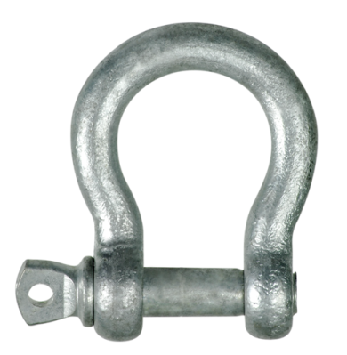
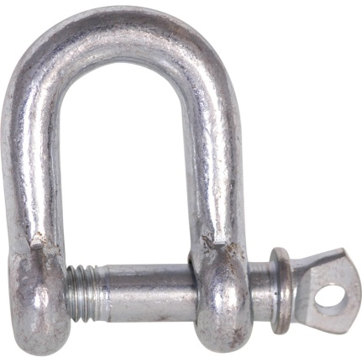
D-Shackles Bow Shacles
(item 44)

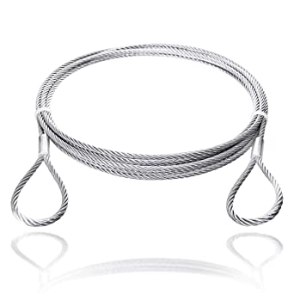
Wire sling Loop-Loop
(item 38/40/43/45)

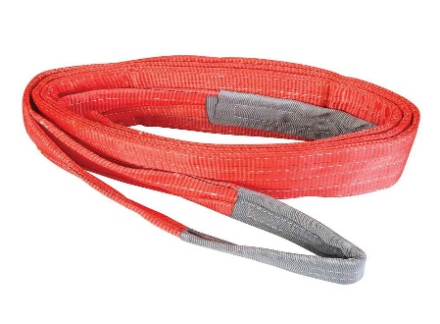
Polyester Sling Belts (item 41)

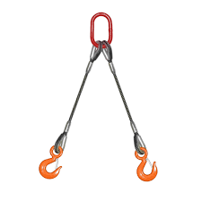
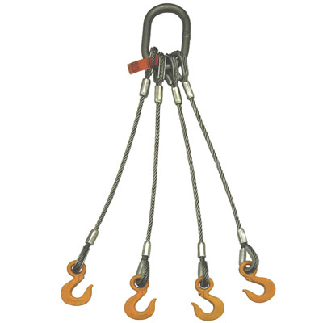
Lifting Slings (item 37) Lifting Slings (item 39)

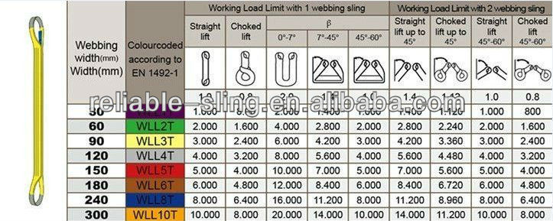
Polyester Sling Belts (item 41)

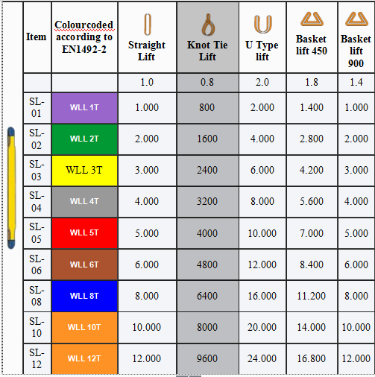
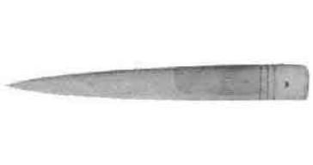
Wooden peg (item 47/48)
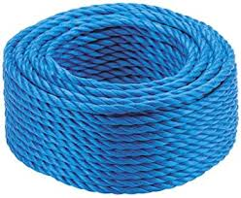
Polypropylene rope ( item 42)

